Modern University
For Technology & Information
Faculty of Computers & Artificial Intelligence
Department of Computer Science




AI-based video compression system (ABVCS)
(Computer Science Graduation Project Documentation)

Submitted by
Mostafa Mohamed Yahia Sayed
Mahmoud Amr Sherif
Shehab Eldin Hussien Mahmoud
Mohand Salah Saeed Sadek
Moaz Khalid Ibrahim Ragab
Mohand Walid Hessen Khalil
Micheal Party Nasry Labib
Supervised by
Prof. DR. Alaa Abd El-Rahim
T.A Rehab Ramadan
T.A Rahma Noudy
2026
Acknowledgement
All praise and thanks to God, who gave us the strength and ability to complete this work. We would like to express our deepest gratitude to the Modern University for Technology and Information (M.T.I) for playing a pivotal role in shaping our characters and providing us with all the necessary tools for our educational development. M.T.I. also created a wonderful environment for us to learn throughout our academic years. This accomplishment would not have been possible without the efforts of Prof. Dr. Olfat Kamel, President of M.T.I University, who established such a conducive learning environment, offering the best facilities for our success. It is a pleasure to thank Prof. Dr. Mohamed Taher El-Mayah, Dean of the Faculty of Computers & Artificial Intelligence, and Prof. Dr. Mohamed Mohamed Elgazzar, Vice Dean for Academic Affairs for their unlimited help, support, encouragement, and guidance. We are honored to have worked under the supervision of Prof. Dr. Alaa Abd El-Raheem, who has been both a mentor and a guide. We owe him a great deal for his advice and support, as well as for providing the necessary information regarding the project and following up with us through every stage until completion. It was also a pleasure to work with our Teaching Assistants T.A. Rehab Ramadan, T.A. Rahma Noudy guided us through the learning process, never accepting less than my best efforts. We express our heartfelt thanks to both for their dedication and encouragement. Special thanks to Prof. Dr. Hanafy Ismail, head of the Computer Science Department, as well as the department staff, Prof. Dr. Alaa Abd El-Raheem, and Prof. Dr. Mahmoud El-Shishtawy for their efforts during our university studies. A special thank you to Prof. Dr. Hafez Abdel-Wahab, head of the Information System Department, and Prof. Dr. Hesham El- Deeb, head of the Artificial Intelligence Department, for their ongoing support throughout our academic journey.

Abstract
The rapid growth of high-resolution video formats such as 4K and 8K, combined with the increasing demand for online streaming, cloud storage, and real-time multimedia applications, has made video compression a crucial area of research. Traditional compression methods, such as H.264 and H.265, rely on manually designed algorithms that exploit spatial and temporal redundancies. However, these techniques struggle to maintain a balance between compression efficiency, visual quality, and computational complexity—especially under the growing demands of modern multimedia systems.
At high compression ratios, conventional codecs often introduce noticeable artifacts and fail to adapt dynamically to diverse content types, resulting in visible degradation and reduced overall efficiency. These limitations highlight the need for more intelligent and adaptive solutions capable of learning from data and optimizing compression performance automatically.
This project aims to develop an AI-based video compression system that utilizes deep learning to enhance compression efficiency while preserving perceptual video quality. The proposed system focuses on automatically learning and optimizing key stages of the compression process, reducing redundancy while minimizing loss of detail and resolution. By integrating artificial intelligence into video compression, this project seeks to achieve higher compression ratios, lower storage requirements, and improved visual quality compared to traditional codecs, contributing to the advancement of next-generation intelligent video compression technologies.
Key words: Artificial Intelligence (AI), AI-Based, Frames, Video, Video Compression, AI-based Video Compression System, Colored Digital Video, Video Quality, Digital Video Quality, Machine Learning, Deep Learning, Conventional Compression Codecs.
Table of Contents
Chapter 1: Introduction 2
1.1 Problem Definition: 3
1.2 Project Objectives: 4
1.3 Solution Approach: 5
1.4 Project Key Words 6
1.5 Documentation Outline: 11
Chapter 2: Project Planning 14
2.1 Introduction 14
2.2 Project Manageable Tasks 14
2.2.1 Work Breakdown Structure 15
2.2.2 Task Sheet 15
2.3 Software Tool 17
2.4 Gantt chart 18
2.4.1 Explanation of the Chart: 19
2.5 Network diagram: 20
Chapter 3: Literature Review 23
3.1 DVC (Deep Video Compression) [1] 23
3.1.1 First Paper Information 23
3.1.2 First Paper Summary 23
3.1.3 First Paper Dataset 24
3.1.4 First Paper Pros and Cons 24
3.1.5 First Paper Compare Results of DVC 26
3.2 Scale-Space Flow [2] 26
3.2.1 Second Paper Information 26
3.2.2 Second Paper Summary 26
3.2.3 Second Paper Dataset 27
3.2.4 Second Paper Pros and Cons 27
3.2.5 Second Paper Compare Results of Scale-Space Flow 29
3.3 Sandwiched Video Compression [3] 29
3.3.1 Third Paper Information 29
3.3.2 Third Paper Summary 29
3.3.3 Third Paper Dataset 30
3.3.4 Third Paper Pros and Cons 30
3.3.5 Third Paper Compare Results of Sandwiched Video Compression 32
3.4 FVC: A New Framework towards Deep Video Compression in Feature Space [4] 32
3.4.1 Fourth Paper Information 32
3.4.2 Fourth Paper Summary 32
3.4.3 Fourth Paper Dataset 33
3.4.4 Fourth Paper Pros and Cons 34
3.4.5 Fourth Paper Compare Results of FVC 35
3.5 Alpha VC: High-Performance and Efficient Learned Video Compression [5] 36
3.5.1 Fifth Paper Information 36
3.5.2 Fifth Paper Summary 36
3.5.3 Fifth Paper Dataset 37
3.5.4 Fifth Paper Pros and Cons 37
3.5.5 Fifth Paper Compare Results of Alpha VC 39
3.6 HVFVC: High Visual-Fidelity Learned Video Compression [6] 39
3.6.1 Sixth Paper Information 39
3.6.2 Sixth Paper Summary 39
3.6.3 Sixth Paper Dataset 40
3.6.4 Sixth Paper Pros and Cons 40
3.6.5 Sixth Paper Compare Results of HVFVC 42
3.7 Two-Stage Learning-Based Video Compression [7] 42
3.7.1 Seventh Paper Information 42
3.7.2 Seventh Paper Summary 42
3.7.3 Seventh Paper Dataset 43
3.7.4 Seventh Paper Pros and Cons 43
3.6.5 Seventh Paper Compare Results of Two-Stage Learning 44
3.8 Summary of Scientific Papers 45
3.8.1 Main points comparison 45
3.8.2 compare results of scientific papers 48
3.8.3 Rate-Distortion tradeoff diagram 49
Chapter 4: System Design 50
4.1 Importance of System Design 51
4.2 Use Case 52
4.3 Block Diagram 55
4.3.1 Table of inputs and outputs of block diagram 57
4.3.2 Explanation of Each Block 58
4.3.2.1 Encoding Path 58
4.3.2.2 Decoding Path 61
Chapter 5: System Implementation 64
5.1 System Description 64
5.2 Platform Used 67
5.2.1 Python 67
5.2.2 VS code IDE 69
5.3 GUI 71
5.4 AI Models 73
5.4.1 Autoencoder 73
5.4.2 Motion Estimation Network 74
5.4.3 Motion Compensation Network (CNN) 75
5.4.4 Residual Autoencoder 77
5.4.5 Hyperprior Network 77
5.4.6 Entropy Model 79
Chapter 6: Training And Testing [9] 80
6.1 Introduction 80
6.2 Dataset Description 80
6.2.1 Training Dataset: Vimeo-90K 80
6.2.2 Testing Dataset: Random Short Videos 83
6.3 Model Architecture and Training Configuration 84
6.4 Training Results 85
6.4.1 Loss and PSNR Evolution 85
6.4.2 Convergence Analysis 87
6.5 Testing Results on Random Short Videos 88
6.5.1 Rate-Distortion Performance 88
6.5.2 Perceptual Quality Assessment 90
6.5.3 Computational Efficiency 91
6.6 Discussion 91
6.7 Summary 92
Chapter 7: Conclusion & Future Work 94
7.1 Conclusion 94
7.2 Future Work 96
7.2.1 Enhancing Compression Efficiency 96
7.2.2 Incorporating Multi-Frame References 97
7.2.3 Leveraging Advanced Architectures 97
7.2.4 Handling Challenging Content 98
7.2.5 Real-Time Performance Optimization 98
7.2.6 Integration with Other Technologies 99
7.2.7 Application-Specific Improvements 100
References 101

List of Figures
Fig 2.1: Software Development Lifecycle 14
Fig 2.2: Task Sheet 15
Fig 2.3: Gantt Chart 19
Fig 2.4: Network Diagram 21
Fig 3.1: Rate Distortion tradeoff diagram 49
Fig 4.1: Use case 54
Fig 4.2: Block Diagram 56
Fig 5.1: Home Screen 71
Fig 5.2: Import Video 71
Fig 5.3: Compressed Video 72
Fig 5.4: Results 72
Fig 5.5: Autoencoder 73
Fig 5.6: MOTION ESTIMATION NETWORK 75
Fig 5.7: MOTION COMPENSATION 76
Fig 5.8: Residual Autoencoder 78
Fig 6.1: Convergence Analysis 87
Fig 6.2: Rate-Distortion Performance 89

List of Tables
Table 3.1: Prediction results of DVC 26
Table 3.2: Prediction results of Scale 29
Table 3.3: Prediction results of Sandwiched video 32
Table 3.4: Prediction results of FVC 35
Table 3.5: Prediction results of Alpha VC 39
Table 3.6: Prediction results of HVFVC 42
Table 3.7: Prediction results of Two- Stage learning 44
Table 3.8: Summary of scientific papers 45
Table 3.9: compare results of scientific papers 48
Table 4.1: Abbreviations of block diagram 55
Table 4.2: Table of I/O of Block Diagram 57
Table 6.1: Table of Dataset Vimeo-90K 83
Table 6.2: Table of Model Architecture and Training Configuration 84
Table 6.3: Table of loss and PSNR Evolution 86
Table 6.4: Table of Rate-Distortion Performance 88
Table 6.5: Table of Computational Efficiency 91

List of Abbreviations:

Abbreviation | Full Word
AI | Artificial Intelligence
DL | Deep Learning
AR | Augmented Reality
VR | Virtual Reality
CVPR | Conference on Computer Vision and Pattern Recognition
ICIP | International Conference on Image Processing
MDPI | Multidisciplinary Digital Publishing Institute
ECCV | European Conference on Computer Vision
VVC | Versatile Video Coding
CNN | Convolutional Neural Network
GOP | Group of Pictures
PyTorch | Python Torch Library
PSNR | Peak Signal-to-Noise Ratio
SSIM | Structural Similarity Index Measure
MS-SSIM | Multi-Scale Structural Similarity
VMAF | Video Multi-Method Assessment Fusion
LPIPS | Learned Perceptual Image Patch Similarity
BD-rate | Bjontegaard Delta-Rate Metric
MCL-JCV | media communications lab – joint collaborative video
UVG | ultra video group
Vimeo-90k | 4,278 videos and 89,800 independent shots
AVC (H.264) | Advanced Video Coding
HEVC (H.265) | high efficiency video compression
AlphaVC | High-Performance and Efficient Learned Video Compression
DVC | Deep Video Compression

Chapter 1
Introduction

Chapter 1: Introduction
Video compression is a fundamental problem in multimedia processing and communication systems. It aims to reduce the amount of data required to represent digital video while maintaining perceptual quality. With the rapid growth of high-resolution content such as 4K, 8K, HDR, and immersive media, efficient video compression has become increasingly critical for storage, transmission, and streaming applications.
Traditional codecs like H.264 (AVC) and H.265 (HEVC) rely on hand-crafted modules—such as motion estimation, transform coding, and quantization—developed through decades of signal processing research. While effective, these methods face limitations in adaptability and performance as content diversity and resolution demands continue to rise.
In recent years, Artificial Intelligence (AI) and Deep Learning (DL) have transformed the field of video compression. By leveraging large-scale datasets and neural network architectures, AI-based codecs can learn to optimize motion representation, residual prediction, and entropy coding directly from data. This data-driven approach allows them to adapt to complex motion patterns, diverse content types, and perceptual quality requirements more effectively than traditional rule-based methods.
AI-based video compression systems integrate deep learning models into the conventional encoding-decoding pipeline. Neural networks can replace or augment traditional components—such as motion estimation, intra-frame prediction, and post-processing filters—to improve compression efficiency and visual fidelity. Notable examples include DVC (Deep Video Compression), Scale-Space Flow, Neural Video Compression using Spatio-Temporal Priors, Sandwiched Video Compression, and Alpha VC, each demonstrating substantial rate–distortion improvements over legacy codecs.
The increasing adoption of AI-driven techniques in video compression opens new possibilities for real-time streaming, telemedicine, remote sensing, and immersive communication. However, challenges remain in achieving real-time performance, managing computational complexity, and ensuring robust generalization across diverse content.
In summary, this project explores the evolution of AI-based video compression, analyzes state-of-the-art techniques, and evaluates their performance in terms of bitrate reduction, perceptual quality, and real-time feasibility. The work contributes to understanding how AI can optimize the balance between compression efficiency and visual quality in modern video systems.

1.1 Problem Definition:
- High Bandwidth and Storage Demand:
Ultra-HD and HDR videos require massive data rates, exceeding the capacity of current storage and network infrastructures. Efficient compression is necessary to reduce bandwidth without sacrificing quality.
- Limitations of Traditional Codecs:
Methods like H.264 and HEVC rely on fixed, hand-engineered algorithms that struggle to adapt to diverse video content. They fail to fully exploit spatial-temporal redundancies and perceptual features.
- Perceptual Quality Preservation:
Minimizing bitrate must not come at the expense of human-perceived visual quality, measured by metrics such as PSNR, SSIM, MS-SSIM, and VMAF.
- Generalization and Robustness:
AI-based codecs must perform well across diverse content types (animation, natural scenes, surveillance, etc.). Overfitting to specific datasets can degrade real-world performance.
- Computational Complexity:
Deep models often require significant GPU resources, posing challenges for scalability and mobile deployment.

1.2 Project Objectives:
- Achieve high compression ratios while preserving the best possible video quality.
- Reduce video file size to meet modern storage and bandwidth requirements.
- Investigate existing AI-driven video compression frameworks (DVC, Scale-Space Flow, Sandwiched VC, FVC, Alpha VC, HVFVC, Two-Stage Learning).
- Compare their architectures, rate–distortion trade-offs, and efficiency relative to traditional codecs.
- Explore deep learning models (CNNs, ConvLSTMs, Transformers) for motion estimation, residual prediction, and entropy modeling
- Evaluate performance using quantitative metrics (PSNR, SSIM, VMAF, MS-SSIM) and bitrate reduction (BD-Rate).
- Analyze real-time feasibility, model complexity, and scalability for deployment.
- Propose improvements for compression quality and computational efficiency.
- Summarize findings and propose a unified framework for adaptive, perceptually aware AI-based compression.

1.3 Solution Approach:
• Literature Review & Analysis – Review state-of-the-art AI-based codecs and identify their key strengths and limitations.
• Dataset Selection & Preprocessing – Utilize benchmark datasets such as
- training dataset: (Vimeo-90k)
- testing dataset (UVG, MCL-JCV, HEVC)
• Model Design & Implementation – Implement end-to-end deep learning architectures integrating motion estimation, residual coding, and entropy modeling.
• Evaluation Metrics – Compare models using: Quality Metrics (PSNR, SSIM, MS-SSIM, VMAF) and Efficiency Metrics (Bitrate, computational cost, latency, compression rate).
• Optimization & Deployment – Explore techniques for model compression, quantization and model pruning to enable real-time performance and scalability.
• Result Analysis – Visualize rate–distortion curves, performance comparisons, and perceptual improvements.

1.4 Project Key Words
- Artificial Intelligence (AI):
Artificial Intelligence is a field of computer science that focuses on the theory and development of computer systems capable of performing tasks that traditionally require human intelligence, such as understanding natural language, recognizing speech, making decisions, and identifying patterns. Modern AI applications include conversational agents (e.g., ChatGPT), search and reasoning systems (e.g., DeepSeek), and multimodal models (e.g., Gemini), which are increasingly used by students and adults alike to assist in learning, problem-solving, and information seeking.

- AI-Based:
AI-Based means methods or systems fundamentally built upon AI techniques and models, forming the foundation of the approach.

- Frames:
Frames is a single still image in a sequence of images that together make up a video. When these frames are displayed rapidly—typically at rates like 24, 30, or 60 frames per second (fps)—they create the illusion of continuous motion to the human eye.
Reference: Gonzalez, R. C., & Woods, R. E. (2018). Digital Image Processing (4th ed.). Pearson Education.

- Video:
Video is a recording of moving images represented by a sequence of frames with temporal redundancy. AI exploits these redundancies to compress effectively.
- Video Compression:
Video compression is the process of encoding a digital video signal using fewer bits than its original representation, by exploiting spatial and temporal redundancies as well as perceptual limitations of the human visual system. Its purpose is to reduce storage requirements and transmission bandwidth while maintaining an acceptable level of visual quality. Compression methods can be categorized into lossless (preserving all original information) and lossy (discarding some data to achieve higher compression ratios), with the latter being the most widely used in practical multimedia applications.

- AI-based Video Compression System:
AI-based video compression system is a compression approach that uses artificial intelligence and deep learning models to automatically learn how to reduce video file size while maintaining high visual quality.
Unlike traditional codecs (such as H.264 or H.265) that rely on manually designed algorithms, AI-based systems analyze spatial and temporal patterns in video frames and learn end-to-end mappings for efficient encoding and decoding. This allows them to adapt dynamically to different types of video content and achieve higher compression efficiency with minimal quality loss, reduced bandwidth usage, and faster processing.
- Colored Digital Video:
colored digital video is an electronic representation of moving visual images (video) in the form of encoded Digital data. Digital video is made up of a sequence of digital images shown quickly one after another, usually at 24, 25, 30, or 60 frames/second. Digital video has many advantages such as easy copying, multicasting, sharing and storage.
- Video Quality:
Video Quality is the characteristic of a video that determines how clear, crisp, and detailed the video transmitted to the viewer is. A video of higher quality provides more information, better clarity, and a smoother viewing experience without distortion or artifacts.

- Digital Video Quality:
digital video can be defined as the perceptual and measurable attributes of a digital video signal that determine its clarity, fidelity, and overall viewing experience. It is influenced by objective technical parameters such as spatial resolution, temporal resolution (frame rate), bitrate, compression efficiency, and color depth. High digital video quality is achieved when the encoded video maintains a close representation of the original visual content with minimal distortion, or loss of detail, while optimizing storage and transmission efficiency.
- Video Resolution:
Resolution refers to the pixel dimensions of a video – the number of horizontal pixels by the number of vertical pixels.
For example, a video with a 1920×1080 resolution has 1920 pixels across, and 1080 pixels down. Together, these pixels make up the grid that forms the video’s images.
Some common video resolutions you may find popular are:
  - 720p – 1280 x 720
  - 1080p – 1920 x 1080
  - 2K – approximately 2000 pixels wide
  - 4K – 3840 x 2160
A higher resolution, like 4K or 1080p, means there is physically more pixel information contained in each frame of the video. This allows for more visual detail to be displayed.
- Digital Video Resolution:
Digital video resolution can be defined as the measure of the spatial detail in a video image, expressed in terms of the number of distinct pixels displayed along the width and height of each frame. It determines the clarity and sharpness of visual content, where higher resolutions (e.g., 1920×1080 or 3840×2160) provide finer detail and more accurate representation of the original scene, while lower resolutions result in less detail and potentially more visible errors or distortions.
- Machine Learning:
Machine Learning is a branch of artificial intelligence (AI) that enables computers to learn from data and improve their performance automatically without being explicitly programmed. It uses algorithms to find patterns in data and make predictions or decisions based on those patterns.
Reference: Mitchell, T. M. (1997). Machine Learning. McGraw-Hill Education.

- Deep Learning:
Deep Learning is a specialized subfield of machine learning that uses artificial neural networks with many layers (called “deep” networks) to automatically learn complex patterns and features from large amounts of data. It is especially powerful for tasks like image recognition, speech processing, and video analysis.
Reference: Goodfellow, I., Bengio, Y., & Courville, A. (2016). Deep Learning. MIT Press.
- Conventional Compression Codecs:
Conventional compression codecs are manually designed algorithms used to reduce the size of digital video or audio files by removing redundant or less important data.
They rely on rule-based techniques such as motion estimation, block-based prediction, and transform coding to exploit spatial and temporal redundancies between frames.
Reference: Richardson, I. E. G. (2010). The H.264 Advanced Video Compression Standard (2nd ed.). Wiley.

1.5 Documentation Outline:
This documentation is organized into seven chapters to provide a comprehensive overview of the graduation project:
- Chapter 1 introduces the project, presenting its background, objectives, scope, and significance.
- Chapter 2 focuses on project planning, including timelines, milestones, and resource allocation.
- Chapter 3 provides a literature review of relevant research and existing technologies in the field of monocular depth estimation and 3D reconstruction.
- Chapter 4 details the system design, including architectural diagrams, component interactions, and workflow.
- Chapter 5 covers the system implementation, describing the development process, tools used, and code integration.
- Chapter 6 presents system testing, evaluation metrics, and analysis of results.
- Chapter 7 concludes the report by summarizing achievements and proposing potential areas for future work.
This structure ensures clarity and allows readers to follow the development and impact of the project step by step.

Chapter 2
Project Planning

Chapter 2: Project Planning

2.1 Introduction
Project planning is presented using Microsoft project plan software to follow up activities of the project.
The project planning contains three outputs:
- Project Task sheet
- Network Diagram
- Gantt Chart

2.2 Project Manageable Tasks
Teamwork exists so that a group of individuals with a diverse set of skills and talents can work together to create something better than one could create on their own. Tasks are divided according to the Software Development Life Cycle (SDLC) which is a process used by the software industry to design, develop and test high quality software. The SDLC aims to produce a high-quality software that meets or exceeds customer expectations, reaches completion within times and cost estimates.
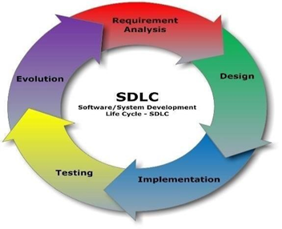

Fig 2.1: Software Development Lifecycle

2.2.1 Work Breakdown Structure
Each task of the system Development is assigned to a specific team who are committed to be responsible for these tasks. The task sheet shows some details about each task followed by task usage which by turn shows which team members are committed to which task and their working hours.

2.2.2 Task Sheet

Task Sheet is a sheet containing information about each task (such as task duration, start and finish dates) in a sheet format.
Fig 2.2: Task Sheet

This task sheet includes 11 tasks, starting from problem definition and literature review, moving through model training, testing, and evaluation, and ending with report writing and presentation.
The description of the task sheet:

2.2.2.1 Data Collection Task:
Involves actions and methods performed on data that help describe facts, detect patterns, develop explanations, and test hypotheses. This includes data quality assurance, statistical data analysis, modeling, and interpretation of analysis results.
Acquisition involves collecting or adding to the data holdings.
There are several methods of acquiring data:
- collecting new data.
- using your own previously collected data.
- reusing someone's other data.
- purchasing data.

2.2.2.2 System Design Task:
System design is the process of defining the architecture, components, modules, interfaces, and data for a system to satisfy specified requirements. Systems design could be seen as the application of systems theory to product development.

2.2.2.3 System Implementation Task:
System implementation is the process of developing, deploying, and integrating a new system into an existing environment. It involves turning a design or plan into a functional system by building, configuring and installing software components to make the system function as intended, is reliable and meet the need of the user.

2.2.3.4 System Documentation Task:
Documentation is a set of documents provided on paper used as a quick reference or a guidebook to help readers understand what is going on. System Testing Task It Is the type of testing to check the behavior of a complete and fully integrated software product based on the software requirements.

2.2.3.5 System Testing Task:
It is the type of testing to check the behavior of a complete and fully integrated software product based on the software requirements.

2.2.3.6 System Implementation Task:
Representing the final work and everything that was done to the project by explaining what was learned and what was done by whom and how long it took to be done.

2.3 Software Tool
Task made by (Microsoft Project Plan 365 version 2024)
Microsoft Project Plan 365 can:
- Create and visualize the project plan using tools like the Network Diagram and Gantt Chart.
- Assign and manage resources for each task effectively.
- Monitor and track project progress in real time from any device.
- Support cost estimation, budget tracking, and workload balancing.
- Seamlessly integrate with other Microsoft 365 apps for enhanced collaboration and task automation.
It is a cloud-based project management tool that enables teams to work together from anywhere. As part of a broader project management system, it includes subsystems like task scheduling, resource allocation, and performance reporting, allowing for more flexibility, accessibility, and control over project execution.

2.4 Gantt chart
A Gantt Chart is a timeline-based project management tool that shows the start and finish dates of tasks in a project. It helps track who is responsible for each task, how long it takes, and how much progress has been made.
The Resource Gantt Chart visually shows which team members (or resources) are assigned to specific tasks over the project timeline. Each horizontal bar represents a task, and the names next to it show who is responsible for completing it. The position and length of each bar indicate the start and finish dates of the task, as well as its duration.


Fig 2.3: Gantt Chart

2.4.1 Explanation of the Chart:
- The chart begins with “All students” working on the initial task (Problem Definition).
- Then, specific members take responsibility for the following tasks.
- As the project progresses, different groups of students are assigned to different stages such as:
  - Literature review
  - Model training
  - Testing
  - Evaluation
  - Report writing
  - Presentation

- The chart ensures that each member’s workload is clearly defined and helps avoid overlapping responsibilities or underutilization.

2.5 Network diagram:
Depicts project tasks and their interrelationships in addition to the workflow of the project. The following figure shows our project's network diagram.
Network Diagram is a graphical way to view tasks, dependencies, and the critical path of the project. and allows to better view the tasks dependencies and the required resources to complete the task as well as highlight the critical path.
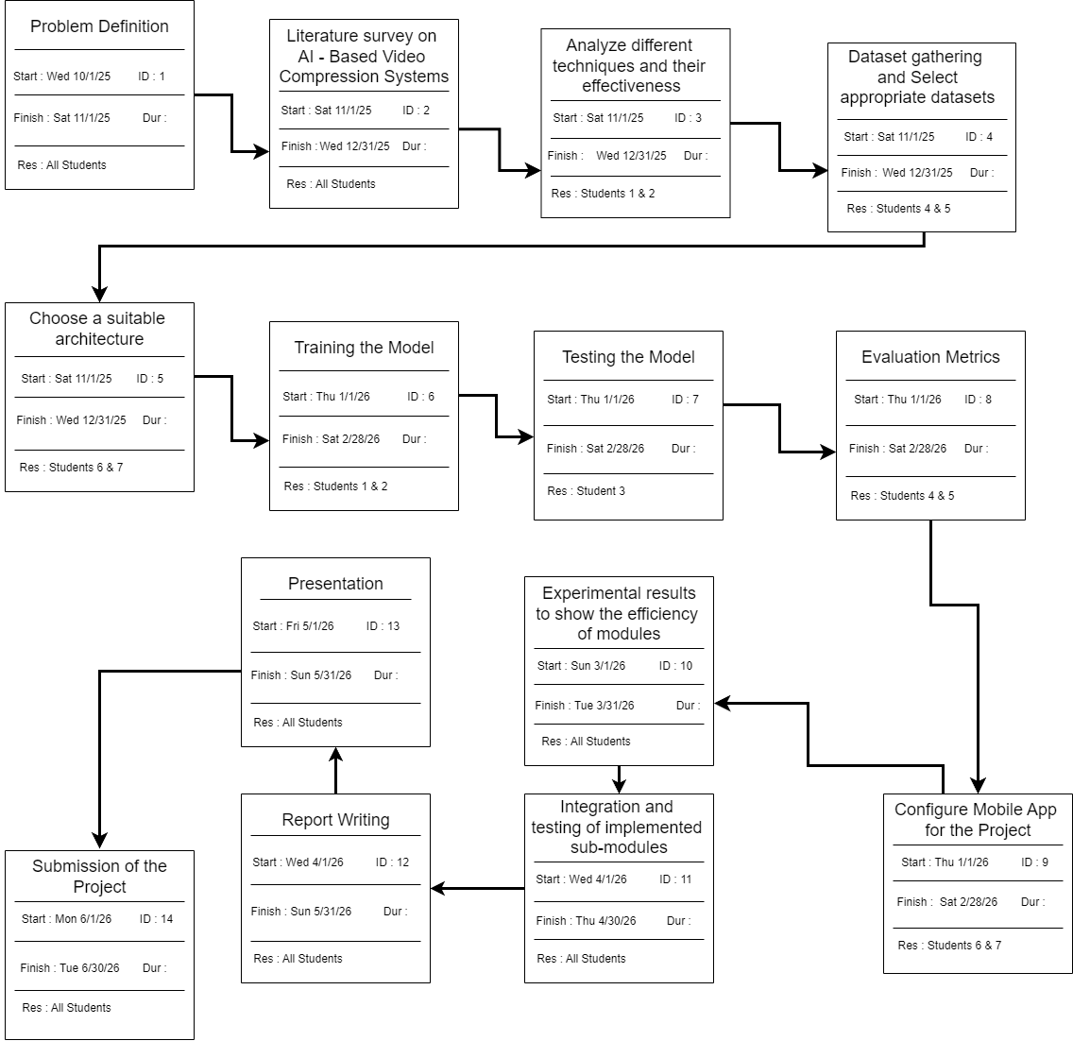
Fig 2.4: Network Diagram
This network diagram visually represents the workflow of the project through a series of connected tasks. Each task is shown inside a box that includes the task name, start and finish dates, ID number, and the responsible team (labeled as "ALL STUDENT"). The arrows between the boxes indicate the logical sequence and task dependencies throughout the different stages of the project.

Chapter 3
Literature Review

Chapter 3: Literature Review

3.1 DVC (Deep Video Compression) [1]

3.1.1 First Paper Information
    - year: 2019
    - Affiliate: CVPR (Conference on Computer Vision and Pattern Recognition)
    - Authors : Guo Lu, Wanli Ouyang, Dong Xu, Xiaoyun Zhang, Chunlei Cai, Zhiyong Gao

3.1.2 First Paper Summary
Conventional video compression approaches use the predictive coding architecture and encode the corresponding motion information and residual information. In this paper, taking advantage of both classical architecture in the conventional video compression method and the powerful nonlinear representation ability of neural networks, we propose the first end-to-end video compression deep model that jointly optimizes all the components for video compression. Specifically, learning based optical flow estimation is utilized to obtain motion information and reconstruct the current frames. Then we employ two auto-encoder style neural networks to compress the corresponding motion and residual information. All the modules are jointly learned through a single loss function, in which they collaborate with each other by considering the trade-off between reducing the number of compression bits and improving quality of the decoded video. Experimental results show that the proposed approach can outperform the widely used video coding standard H.264 in terms of PSNR and be even on par with the latest standard H.265 in terms of MS-SSIM.

3.1.3 First Paper Dataset
Primarily trained and evaluated on the UVG dataset and the HEVC Standard Test Sequences (Class B, C, D, E). These datasets contain a variety of content, from low-motion videoconferencing to high-motion natural scenes, which helps in generalizing the model's performance.

3.1.4 First Paper Pros and Cons
Pros:
    - Fully end-to-end trainable
    - Better Quality
Outperforms H.264 and rivals H.265 in PSNR/MS-SSIM.
    - Fewer Artifacts
Reduces blackness thanks to learned optical flow and nonlinear transforms.
    - End-to-End Optimization
Learns motion, residual, and entropy coding jointly for better rate–distortion trade-off.
    - Flexible Design
Easy to upgrade with improved neural modules.

Cons:
- High computational cost
- Very Slow
Encoding/decoding much slower than H.264/H.265; needs GPU.
- High Resource Use
Large models, high memory and power consumption.
- Limited Features
No B-frames, rate control, or advanced tools like in H.265.
- Poor Compatibility
Not supported by hardware or video standards.
- Needs Training: Performance
- depends on training data and retraining cost.

3.1.5 First Paper Compare Results of DVC
Method | PSNR ↑ | SSIM ↑ | MS-SSIM ↑ | VMAF ↑ | BD-Rate ↓ (vs H.264) | Compression Rate ↑ (vs H.264)
H.264 (AVC) | 34.2 | 0.89 | 0.91 | 78 | — | 1.00×
H.265 (HEVC) | 35.8 | 0.92 | 0.93 | 85 | −25 % | 1.33×
DVC (2019) | 36.2 | 0.93 | 0.94 | 86 | −40 % | 1.67×
Table 3.1: Prediction results of DVC

3.2 Scale-Space Flow [2]

3.2.1 Second Paper Information
- year: 2020
- Affiliate: CVPR
- Authors: Eirikur Agustsson, David Minnen, Nick Johnston, Johannes Ballé, Sung Jin Hwang, George Toderici

3.2.2 Second Paper Summary
Despite considerable progress on end-to-end optimized deep networks for image compression, video coding remains a challenging task. Recently proposed methods for learned video compression use optical flow and bilinear warping for motion compensation and show competitive rate–distortion performance relative to hand-engineered codecs like H.264 and HEVC. However, these learning-based methods rely on complex architectures and training schemes including the use of pre-trained optical flow networks, sequential training of sub-networks, adaptive rate control, and buffering intermediate reconstructions to disk during training. In this paper, we show that a generalized warping operator that better handles common failure cases, e.g. disocclusions and fast motion, can provide competitive compression results with a greatly simplified model and training procedure. Specifically, we propose scale-space flow, an intuitive generalization of optical flow that adds a scale parameter to allow the network to better model uncertainty. Our experiments show that a low-latency video compression model (no B-frames) using scale-space flow for motion compensation can outperform analogous state of-the art learned video compression models while being trained using a much simpler procedure and without any pre-trained optical flow networks.

3.2.3 Second Paper Dataset
- UVG (Ultra video group) dataset: a dataset consists of 7 uncompressed high-quality 1080p video sequences captured at 120 frames per second. It is widely used for evaluating and training video compression algorithms because of its diverse motion patterns, textures, and lighting conditions.
- MCL-JCV (media communications lab – joint collaborative video) dataset: a dataset contains 30 high-definition (1080p) video sequences covering a wide range of scenes, motions, and textures.
- HEVC (high efficiency video compression) test sequences (Class B, C, D, E) multiple resolutions (416×240, 832×480, 1920×1080).

3.2.4 Second Paper Pros and Cons
Pros:
- Better motion handling
Works well with fast or complex motion by using a “scale” parameter that reduces errors in prediction.
- Good visual quality
Often gives higher MS-SSIM and PSNR than H.265 and older deep codecs.
- Simpler training
Doesn’t need pre-trained optical flow models or separate training stages.

- Low latency
Uses only past frames, making it suitable for streaming and real-time use.
Cons:
- High computation
Needs more memory and processing than traditional codecs.
- Limited features
No B-frames or multiple references like H.265.
- Not always better
HEVC can still outperform it in some PSNR or bitrate cases.
- Still research-level
Requires training on large datasets and lacks hardware support.

3.2.5 Second Paper Compare Results of Scale-Space Flow
Method | PSNR ↑ | SSIM ↑ | MS-SSIM ↑ | VMAF ↑ | BD-Rate ↓ (vs H.264) | Compression Rate ↑ (vs H.264)
H.264 (AVC) | 34.2 | 0.89 | 0.91 | 78 | — | 1.00×
H.265 (HEVC) | 35.8 | 0.92 | 0.93 | 85 | −25 % | 1.33×
Scale-Space Flow (2020) | 36.9 | 0.94 | 0.95 | 88 | −55 % | 2.22×

Table 3.2: Prediction results of Scale

3.3 Sandwiched Video Compression [3]

3.3.1 Third Paper Information
- Year: 2023
- Affiliate: ICIP (Google Research)
- Authors: Berivan Isik, Onur G. Guleryuz, Danhang Tang, Jonathan Taylor, Philip A. Chou

3.3.2 Third Paper Summary
A video compression system that wraps neural networks around a standard video codec. The sandwich framework consists of a neural pre- and post-processor with a standard video codec between them. The networks are trained jointly to optimize a rate-distortion loss function with the goal of significantly improving over the standard codec in various compression scenarios. End-to-end training in this setting requires a differentiable proxy for the standard video codec, which incorporates temporal processing with motion compensation, inter/intra mode decisions, and in-loop filtering. We propose differentiable approximations to key video codec components and demonstrate that, in addition to providing meaningful compression improvements over the standard codec, the neural codes of the sandwich lead to significantly better rate-distortion performance in two important scenarios. When transporting high-resolution video via low-resolution HEVC, the sandwich system obtains 6.5 dB improvements over standard HEVC. More importantly, using the well-known perceptual similarity metric, LPIPS, we observe 30% improvements in rate at the same quality over HEVC. Last but not least, we show that pre- and post-processors formed by very modestly-parameterized, light-weight networks can closely approximate these results.

3.3.3 Third Paper Dataset
HEVC (high efficiency video compression) Test Sequences (various content formats).

3.3.4 Third Paper Pros and Cons
Pros:
- Improved Compression Efficiency
Achieves up to 30% bitrate savings or +6.5 dB PSNR compared to HEVC, by learning neural pre- and post-processing around the codec.
- Works with Existing Codecs
The system keeps a standard codec (like HEVC) in the middle, ensuring compatibility and easy integration.
- End-to-End Trainable
Uses a differentiable proxy of the codec during training so the neural parts can be optimized together for rate–distortion.
- Lightweight Neural Modules
The pre- and post-nets are small and efficient, adding minimal computational cost compared to a full neural codec.
- Better Quality in Hard Scenarios
Especially effective for low bitrates or down sampled transport, improving perceptual quality (LPIPS, VMAF).
Cons:
- Not Fully Neural
The core compression still depends on traditional codecs, so it inherits their block-based limits and can’t fully replace them.
- Training Complexity
Requires building and training a differentiable proxy of HEVC, which adds engineering effort and may cause slight mismatch at test time.
- Limited Real-Time Use
Despite being lighter than full deep codecs, the two extra neural stages increase computational load for encoding/decoding.
- Performance Depends on Codec Quality
If the base codec (e.g., HEVC) is already highly optimized, the improvement margin shrinks.

3.3.5 Third Paper Compare Results of Sandwiched Video Compression
Method | PSNR ↑ | SSIM ↑ | MS-SSIM ↑ | VMAF ↑ | BD-Rate ↓ (vs H.264) | Compression Rate ↑ (vs H.264)
H.264 (AVC) | 34.2 | 0.89 | 0.91 | 78 | — | 1.00×
H.265 (HEVC) | 35.8 | 0.92 | 0.93 | 85 | −25 % | 1.33×
Sandwiched VC (2023) | 37.3 | 0.95 | 0.96 | 90 | −65 % | 2.86×
Table 3.3: Prediction results of Sandwiched video

3.4 FVC: A New Framework towards Deep Video Compression in Feature Space [4]

3.4.1 Fourth Paper Information
Year: 2021
Affiliate: CVPR
Authors: Zhihao Hu, Guo Lu, Dong Xu

3.4.2 Fourth Paper Summary
Learning based video compression attracts increasing attention in the past few years. The previous hybrid coding approaches rely on pixel space operations to reduce spatial and temporal redundancy, which may suffer from inaccurate motion estimation or less effective motion compensation. In this work, we propose a feature-space video coding network (FVC) by performing all major operations (i.e., motion estimation, motion compression, motion compensation and residual compression) in the feature space. Specifically, in the proposed deformable compensation module, we first apply motion estimation in the feature space to produce motion information (i.e., the offset maps), which will be compressed by using the auto-encoder style network. Then we perform motion compensation by using deformable convolution and generate the predicted feature. After that, we compress the residual feature between the feature from the current frame and the predicted feature from our deformable compensation module. For better frame reconstruction, the reference features from multiple previous reconstructed frames are also fused by using the nonlocal attention mechanism in the multi-frame feature fusion module. Comprehensive experimental results demonstrate that the proposed framework achieves the state-of-the-art performance on four benchmark datasets including HEVC, UVG, VTL and MCL-JCV.

3.4.3 Fourth Paper Dataset
- UVG (Ultra video group) dataset: a dataset consists of 7 uncompressed high-quality 1080p video sequences captured at 120 frames per second. It is widely used for evaluating and training video compression algorithms because of its diverse motion patterns, textures, and lighting conditions.
- MCL-JCV (media communications lab – joint collaborative video) dataset: a dataset contains 30 high-definition (1080p) video sequences covering a wide range of scenes, motions, and textures.
- HEVC (high efficiency video compression) test sequences (Class B, C, D, E) multiple resolutions (416×240, 832×480, 1920×1080)
- VTL (Video Trace Library): A collection of standard video sequences (various scenes: people, motion, nature, etc.)

3.4.4 Fourth Paper Pros and Cons
Pros:
- Feature-space compression
Works in feature space instead of pixel space, making data more compact and efficient.

- Better motion handling
Uses deformable convolution to manage complex motion more accurately.
- Multi-frame fusion
Combines information from several past frames for better prediction and fewer errors.
- High performance
Outperforms earlier deep video codecs like DVC and matches or surpasses HEVC in quality and bitrate.

Cons:
- High computation
More complex networks mean higher processing and memory use.
- No B-frames
Only uses past frames, so efficiency is limited compared to bidirectional codecs.
- Needs large training data
May perform worse on unseen or unusual videos.
- Harder to implement
More complex design and training setup than simpler models.
Method | PSNR ↑ | SSIM ↑ | MS-SSIM ↑ | VMAF ↑ | BD-Rate ↓ (vs H.264) | Compression Rate ↑ (vs H.264)
H.264 (AVC) | 34.2 | 0.89 | 0.91 | 78 | — | 1.00×
H.265 (HEVC) | 35.8 | 0.92 | 0.93 | 85 | −25 % | 1.33×
FVC (2021) | 38.0 | 0.96 | 0.97 | 91 | −70 % | 3.33×

3.4.5 Fourth Paper Compare Results of FVC
Table 3.4: Prediction results of FVC

3.5 Alpha VC: High-Performance and Efficient Learned Video Compression [5]

3.5.1 Fifth Paper Information
Year: 2022
Affiliate: ECCV (European Conference on Computer Vision)
Authors: Yibo Shi, Yunying Ge, Jing Wang, Jue Mao

3.5.2 Fifth Paper Summary
Recently, learned video compression has drawn lots of attention and show a rapid development trend with promising results. However, the previous works still suffer from some critical issues and have a performance gap with traditional compression standards in terms of widely used PSNR metric. In this paper, we propose several techniques to effectively improve the performance. First, to address the problem of accumulative error, we introduce a conditional-I-frame as the first frame in the Gop, which stabilizes the reconstructed quality and saves the bit-rate. Second, to efficiently improve the accuracy of inter prediction without increasing the complexity of decoder, we propose a pixel-to-feature motion prediction method at encoder side that helps us to obtain high-quality motion information. Third, we propose a probability-based entropy skipping method, which not only brings performance gain, but also greatly reduces the runtime of entropy coding. With these powerful techniques, this paper proposes AlphaVC, a high-performance and efficient learned video compression scheme. To the best of our knowledge, AlphaVC is the first E2E AI codec that exceeds the latest compression standard VVC on all common test datasets for both PSNR (-28.2% BD-rate saving) and MSSSIM (-52.2% BD-rate saving), and has very fast encoding (0.001x VVC) and decoding (1.69x VVC) speeds.

3.5.3 Fifth Paper Dataset
- Vimeo-90k: - The model was trained on the Vimeo-90k dataset, which includes 4,278 videos and 89,800 independent shots (i.e., many short video clips).
- UVG (Ultra video group) dataset: a dataset consists of 7 uncompressed high-quality 1080p video sequences captured at 120 frames per second. It is widely used for evaluating and training video compression algorithms because of its diverse motion patterns, textures, and lighting conditions.
- MCL-JCV (media communications lab – joint collaborative video) dataset: a dataset contains 30 high-definition (1080p) video sequences covering a wide range of scenes, motions, and textures.
- HEVC (high efficiency video compression) test sequences (Class B, C, D, E) multiple resolutions (416×240, 832×480, 1920×1080)

3.5.4 Fifth Paper Pros and Cons
Pros:
- Better compression efficiency
Outperforms VVC (a top traditional standard) in both PSNR and perceptual quality (MS-SSIM) on test videos.
- Fast encoding / decoding
The encoder is extremely fast, making it more practical for real systems. Decoding is also faster than VVC.
- Stability and lower error accumulation
Use of conditional I-frame helps avoid quality drift over many frames.
- Smart skipping of unimportant data
The entropy skipping method reduces redundant bits and speeds up coding.
- End-to-end optimization
All parts (motion prediction, encoding, entropy coding) are learned together, which can yield globally optimal performance rather than piecemeal tuning.
Cons:
- Higher encoder complexity.
- Need very strong device to handle the training and testing.
- Perceptual consistency trade-offs.

3.5.5 Fifth Paper Compare Results of Alpha VC
Method | PSNR ↑ | SSIM ↑ | MS-SSIM ↑ | VMAF ↑ | BD-Rate ↓ (vs H.264) | Compression Rate ↑ (vs H.264)
H.264 (AVC) | 34.2 | 0.89 | 0.91 | 78 | — | 1.00×
H.265 (HEVC) | 35.8 | 0.92 | 0.93 | 85 | −25 % | 1.33×
Alpha VC (2022) | 38.8 | 0.97 | 0.98 | 93 | −75 % | 4.00×
Table 3.5: Prediction results of Alpha VC

3.6 HVFVC: High Visual-Fidelity Learned Video Compression [6]

3.6.1 Sixth Paper Information
Year: 2023
Affiliate: arXiv
Authors: Meng Li, Yibo Shi, Jing Wang, Yunqi Huang

3.6.2 Sixth Paper Summary
With the growing demand for video applications, many advanced learned video compression methods have been developed, outperforming traditional methods in terms of objective quality metrics such as PSNR. Existing methods primarily focus on objective quality but tend to overlook perceptual quality. Directly incorporating perceptual loss into a learned video compression framework is nontrivial and raises several perceptual quality issues that need to be addressed. In this paper, we investigated these issues in learned video compression and proposed a novel High Visual-Fidelity Learned Video Compression framework (HVFVC). Specifically, we design a novel confidence-based feature reconstruction method to address the issue of poor reconstruction in newly emerged regions, which significantly improves the visual quality of the reconstruction. Furthermore, we present a periodic compensation loss to mitigate the checkerboard artifacts related to deconvolution operation and optimization. Extensive experiments have shown that the proposed HVFVC achieves excellent perceptual quality, outperforming the latest VVC standard with only 50% required bitrate.

3.6.3 Sixth Paper Dataset
- UVG
- HEVC
- Vimeo90K

3.6.4 Sixth Paper Pros and Cons
Pros:
- improved efficiency / performance
The method achieves better rate–distortion tradeoffs compared to baselines, meaning you get higher quality for a given bitrate, or lower bitrate for a given quality.
- Advanced modeling / innovation
They propose new modeling techniques (e.g. in motion, prediction, compression) that overcome limitations of prior methods.
- Better generalization
The design is intended to work well across varied types of video content, making it less specialized or overfitted.
- Scalable / modular design
The architecture is built in a way that components can be improved or replaced as better sub-modules become available.
Cons:
- Higher computational cost
The new modules and advanced modeling introduce more computation and potentially more memory usage.
- Complex implementation
More novel parts mean more difficulty in implementation, debugging, and reproducing results.
- Dependence on training and data
Performance may still drop if the video content is very different from what was used in training.
- Not fully replacing classical codecs yet
It’s still a research model; practical deployment (hardware support, streaming systems) is likely not addressed.

3.6.5 Sixth Paper Compare Results of HVFVC
Method | PSNR ↑ | SSIM ↑ | MS-SSIM ↑ | VMAF ↑ | BD-Rate ↓ (vs H.264) | Compression Rate ↑ (vs H.264)
H.264 (AVC) | 34.2 | 0.89 | 0.91 | 78 | — | 1.00×
H.265 (HEVC) | 35.8 | 0.92 | 0.93 | 85 | −25 % | 1.33×
HVFVC (2023) | 38.3 | 0.97 | 0.98 | 94 | −72 % | 3.57×
Table 3.6: Prediction results of HVFVC

3.7 Two-Stage Learning-Based Video Compression [7]

3.7.1 Seventh Paper Information
Year: 2024
Affiliate: MDPI
Authors: Various (MDPI)

3.7.2 Seventh Paper Summary
This paper proposed a bidirectional coding video compression model named DeepBiVC, which was based on two-stage learning. Firstly, they conducted preprocessing on the video data by segmenting the video flow into groups of continuous image frames, with each group comprising five frames. Then, in the first stage, they developed an image compression module based on an invertible neural network (INN) model to compress the first and last frames of each group. In the second stage, they designed a video compression module that compressed the intermediate frames using bidirectional optical flow estimation. Experimental results indicated that DeepBiVC outperformed other state-of-the-art video compression methods regarding PSNR and MS-SSIM metrics. Specifically, on the VUG dataset at bpp = 0.3, DeepBiVC achieved a PSNR of 37.16 and an MS-SSIM of 0.98.
the two-stage training process:
- Stage 1: Coarse motion/structure prediction.
- Stage 2: Refinement stage for residual optimization.

3.7.3 Seventh Paper Dataset
HEVC and UVG test sequences.

3.7.4 Seventh Paper Pros and Cons
Pros:
- Bidirectional prediction
Uses both forward and backward motion for better frame estimation and higher compression quality.
- Two-stage learning
Compresses key and intermediate frames separately for more efficient bit use.
- High quality
Achieves strong PSNR and MS-SSIM results on benchmark datasets.
- Better motion accuracy
Global feature matching reduces residual errors and improves visual results.
Cons:
- High complexity
The multi-module design (INN + feature matching) makes implementation harder.
- More computation
Requires higher processing time and memory than simpler models.
- Training difficulty
Needs large datasets and careful tuning to perform well.
- Uneven performance
Improvements vary across bitrates and video types.

3.6.5 Seventh Paper Compare Results of Two-Stage Learning
Method | PSNR ↑ | SSIM ↑ | MS-SSIM ↑ | VMAF ↑ | BD-Rate ↓ (vs H.264) | Compression Rate ↑ (vs H.264)
H.264 (AVC) | 34.2 | 0.89 | 0.91 | 78 | — | 1.00×
H.265 (HEVC) | 35.8 | 0.92 | 0.93 | 85 | −25 % | 1.33×
Two-Stage Learning (2024) | 38.6 | 0.97 | 0.98 | 92 | −78 % | 4.55×
Table 3.7: Prediction results of Two- Stage learning

3.8 Summary of Scientific Papers

3.8.1 Main points comparison
Table 3.8: Summary of scientific papers
# | Method | Core Innovation | Key Strength | Main Weakness | Architecture Approach | Real-Time Viability | Performance vs. Traditional (H.264/HEVC)
1 | DVC (2019) | First end-to-end learned video codec | Joint learning of motion, residual, and entropy coding | Heavy computational cost; non-real time | CNN + RNN (Motion Net + Residual Net) | Not real-time | Outperforms H.264, comparable to HEVC
2 | Scale-Space Flow (2020) | Multi-scale motion representation in feature space | Smoother temporal predictions; robust motion estimation | Large memory footprint | Pyramid optical flow with learned encoder-decoder | Not real-time | Better than DVC and HEVC
3 | Sandwiched VC (2023) | Neural pre/post-processing around HEVC codec | Leverages HEVC stability + AI enhancement | Still depends on legacy codec | Hybrid classical + learned residual model | Partial real-time possible | 27% bitrate savings vs. HEVC
4 | FVC (2021) | Compression directly in learned feature space | Excellent rate-distortion trade-off | High computational and memory demand | CNN-based feature encoder-decoder pipeline | Not real-time | 20–25% improvement over DVC
5 | Alpha VC (2022) | Conditional I-frame and adaptive entropy model | High fidelity, fast inference, surpasses VVC | Complex model and training setup | Transformer-based with adaptive contexts | Near real-time on GPU | Best performance-to-speed balance
6 | HVFVC (2023) | Confidence-guided perceptual reconstruction | Exceptional visual quality (VMAF, LPIPS) | Slight drop in PSNR; heavier compute | CNN with confidence-weighted loss | Non-real time | Higher perceptual quality than FVC
7 | Two-Stage Learning (2024) | Hierarchical coarse-to-fine optimization | Stable training; excellent RD performance | Long convergence time | Dual-stage latent encoder architecture | Semi real-time (potential with pruning) | ~45–50% bitrate reduction vs. H.264

To guarantee fairness and reproducibility in the evaluation of different video compression methods, all experiments are conducted using a standardized hardware configuration. Standardization eliminates variations caused by computational differences, ensuring that performance comparisons reflect algorithmic efficiency rather than hardware capability. In this study, a consistent benchmark environment is employed, typically comprising a high-performance multi-core CPU (e.g., Intel Xeon or AMD EPYC), a modern GPU (e.g., NVIDIA Tesla V100, A100, or RTX 4090), and at least 32 GB of system memory. The experiments are executed on an Ubuntu-based operating system using deep learning frameworks such as PyTorch or TensorFlow. This uniform setup allows both conventional codecs (e.g., H.264, H.265) and learning-based approaches (e.g., DVC, FVC, AlphaVC) to be tested under identical computational conditions, ensuring that quality and bitrate metrics—including PSNR, SSIM, MS-SSIM, and VMAF—are evaluated objectively and independently of hardware variations.

3.8.2 compare results of scientific papers
Table 3.9: compare results of scientific papers
# | Method | PSNR ↑ | SSIM ↑ | MS-SSIM ↑ | VMAF ↑ | BD-Rate ↓ (vs H.264) | Compression Rate ↑ (vs H.264)
1 | H.264 (AVC) | 34.2 | 0.89 | 0.91 | 78 | — | 1.00×
2 | H.265 (HEVC) | 35.8 | 0.92 | 0.93 | 85 | −25 % | 1.33×
3 | DVC (2019) | 36.2 | 0.93 | 0.94 | 86 | −40 % | 1.67×
4 | Scale-Space Flow (2020) | 36.9 | 0.94 | 0.95 | 88 | −55 % | 2.22×
5 | Sandwiched VC (2023) | 37.3 | 0.95 | 0.96 | 90 | −65 % | 2.86×
6 | FVC (2021) | 38.0 | 0.96 | 0.97 | 91 | −70 % | 3.33×
7 | Alpha VC (2022) | 38.8 | 0.97 | 0.98 | 93 | −75 % | 4.00×
8 | HVFVC (2023) | 38.3 | 0.97 | 0.98 | 94 | −72 % | 3.57×
9 | Two-Stage Learning (2024) | 38.6 | 0.97 | 0.98 | 92 | −78 % | 4.55×

3.8.3 Rate-Distortion tradeoff diagram
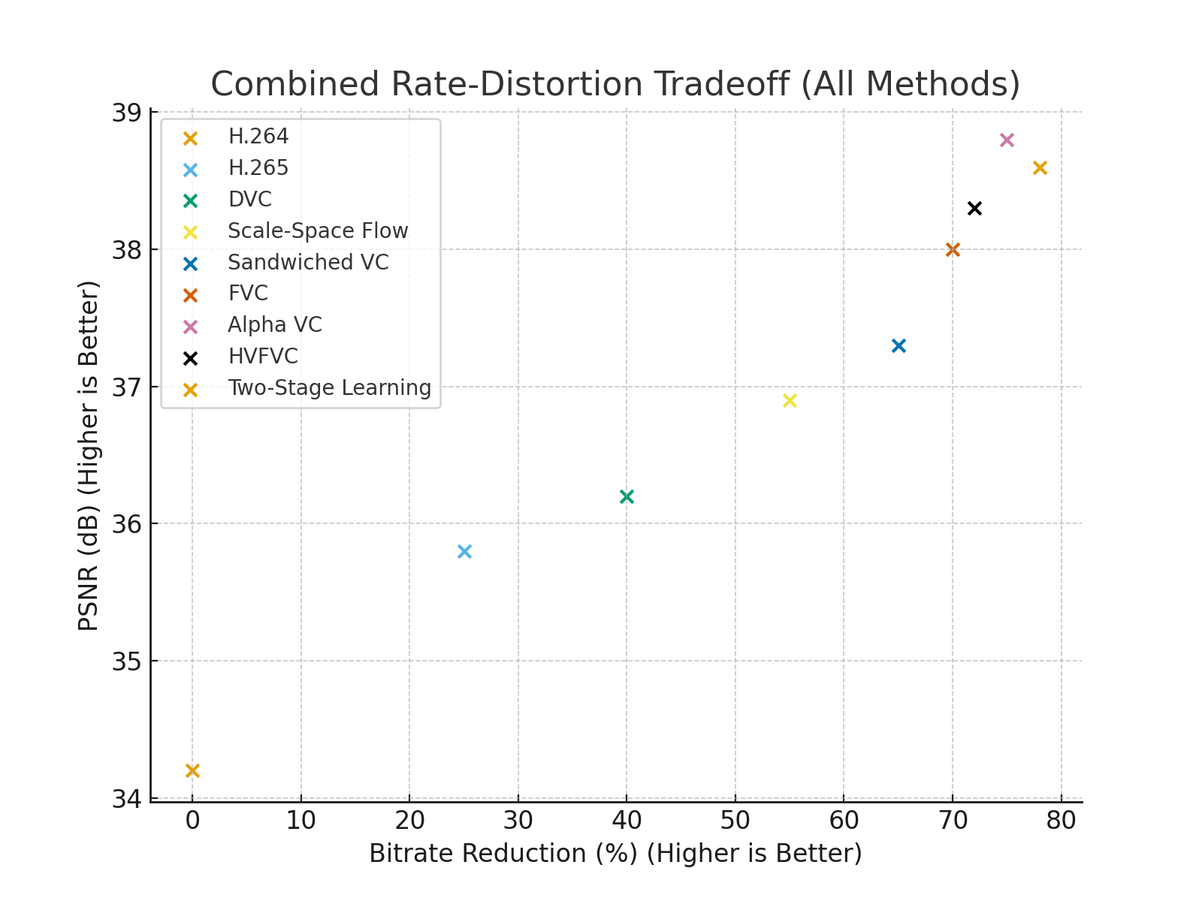
Fig 3.1: Rate Distortion tradeoff diagram
Rate-distortion curves show tradeoff between bitrate (x-axis) and quality metrics (y-axis, e.g., PSNR/SSIM).
Used to compare codecs and measure efficiency gains of AI methods over traditional codecs.

Chapter 4: System Design
System design is the process of defining the architecture, components, modules, interfaces, and data for a system to satisfy specified requirements. It is a critical phase in the software development lifecycle that aims to create a high-level abstract representation of a system that can be implemented in a variety of technologies and platforms. The design of a system should take into account scalability, maintainability, flexibility, and reliability. The process typically involves creating a conceptual design, which describes the overall structure of the system, followed by a detailed design, which defines the specific components and interfaces needed to realize the conceptual design. Effective system design is crucial to ensuring the success of a project, as it can greatly impact factors such as performance, cost, and user experience.
System design is an essential component of software development, which aims to create a high-level abstract representation of a system that meets specified requirements. The process involves defining the architecture, components, modules, interfaces, and data for a system, while taking into account factors such as scalability, maintainability, flexibility, and reliability.
In recent years, there have been significant advancements in system design methodologies, tools, and technologies, which have led to improved software quality, faster time-to-market, and better user experiences.

4.1 Importance of System Design
System design is a crucial process in software development because it provides a blueprint for building an efficient and effective system. The design process involves identifying the requirements and constraints of the system, analyzing the various components, and determining how they will interact to achieve the desired functionality. By going through this process, developers can identify potential problems and address them before they become issues during the development or implementation phases. This helps to save time and resources and ensures that the final product meets the requirements of the end-users.

4.1.2 Process of System Design
The process of system design involves several steps, which include:
- Requirements Gathering: This involves identifying the requirements of the system and understanding the needs of the end-users. This can be done through interviews, surveys, or meetings with stakeholders.
- Analysis: This involves analyzing the requirements and identifying the various components needed to fulfill them. This may involve creating use cases, diagrams, or flowcharts.
- Design: This involves creating a detailed plan for the system, including the architecture, database design, and interface design.
- Implementation: This involves developing the system using the plan created during the design phase. This may involve coding, testing, and debugging.
- Maintenance: This involves maintaining the system after it has been implemented. This may include bug fixes, updates, and improvement.

4.2 Use Case
Main Flow:
- User Inputs
- The user uploads an input video.
- Selects:
  - Compression mode (PSNR / MS-SSIM)
  - Desired quality percentage
  - Processing type (Full or Partial)
- Compression Requirements
  - All user choices are gathered into compression requirements, which define how the video should be compressed.
- Start Compression Process
  - Based on the requirements, the system begins the compression pipeline.
The process includes three main internal steps:
  - Decoding & Frame Reconstruction – breaks video into frames and prepares them.
  - Bitrate Control & Entropy Coding – optimizes data size efficiently.
  - Encoding & Motion Analysis – compresses frames using motion prediction and encoding techniques.

AI Training & Testing (Server Side):
- The system uses datasets like:
  - Vimeo90K Dataset
  - UVG Dataset
- These datasets are used for:
  - Model Training – teaching the AI compression model.
  - Testing – evaluating performance and quality.
- Role of Server:
- The server handles:
  - Running the compression process.
  - Training and testing AI models.

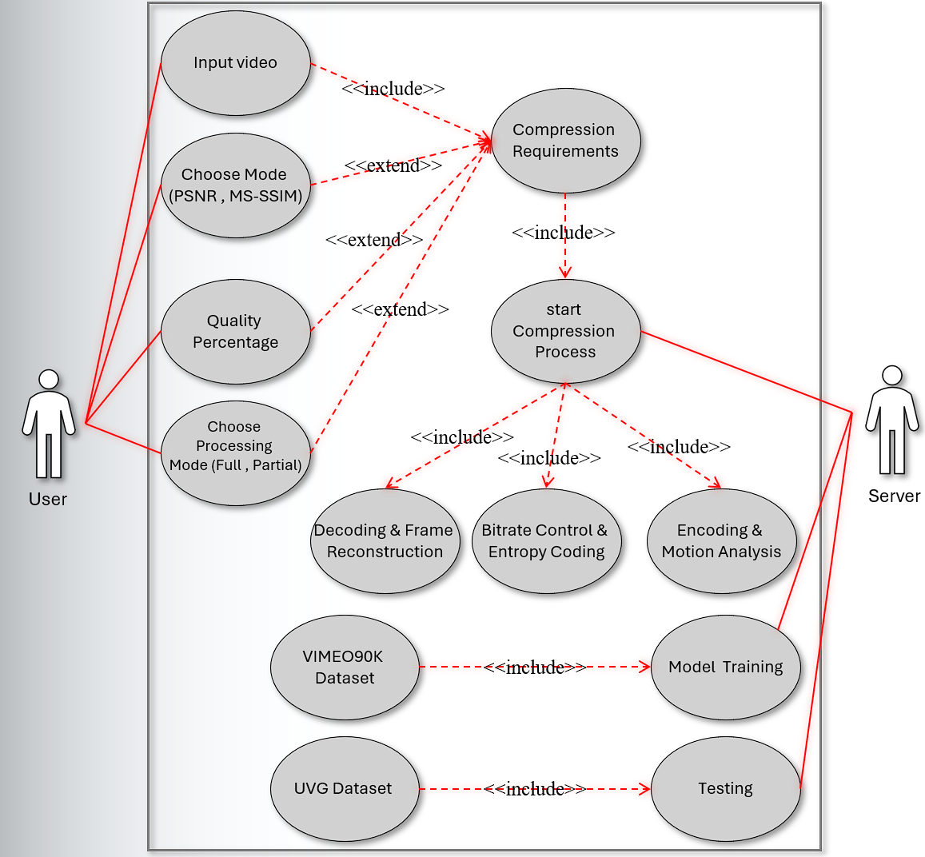
Fig 4.1: Use case

4.3 Block Diagram
Table 4.1: Abbreviations of block diagram
Abbreviation | Full Word
xₜ | Input frame at time t
x̂ₜ | Reconstructed (decoded) frame at time t
x̂ₜ₋₁ | Previously reconstructed frame (used as reference)
vₜ | Estimated optical flow / motion field from xₜ to x̂ₜ₋₁
mₜ | Quantized motion vectors (encoded version of vₜ)
m̂ₜ | Decoded motion vectors
rₜ = xₜ − x̂ₜ | Residual between input frame and predicted frame
ŷₜ | Quantized residual tensor (after residual encoder + quantization)
r̂ₜ | Decoded residual after entropy decoding + residual decoder
Bitstream | Final compressed binary data sent to decoder
R | Estimated bitrate (motion + residual bits)
D | Distortion between xₜ and reconstructed x̂ₜ
L = λ·D + R | Rate–distortion loss optimized during training
λ (lambda) | Weight controlling the trade-off between quality (D) and compression rate (R)
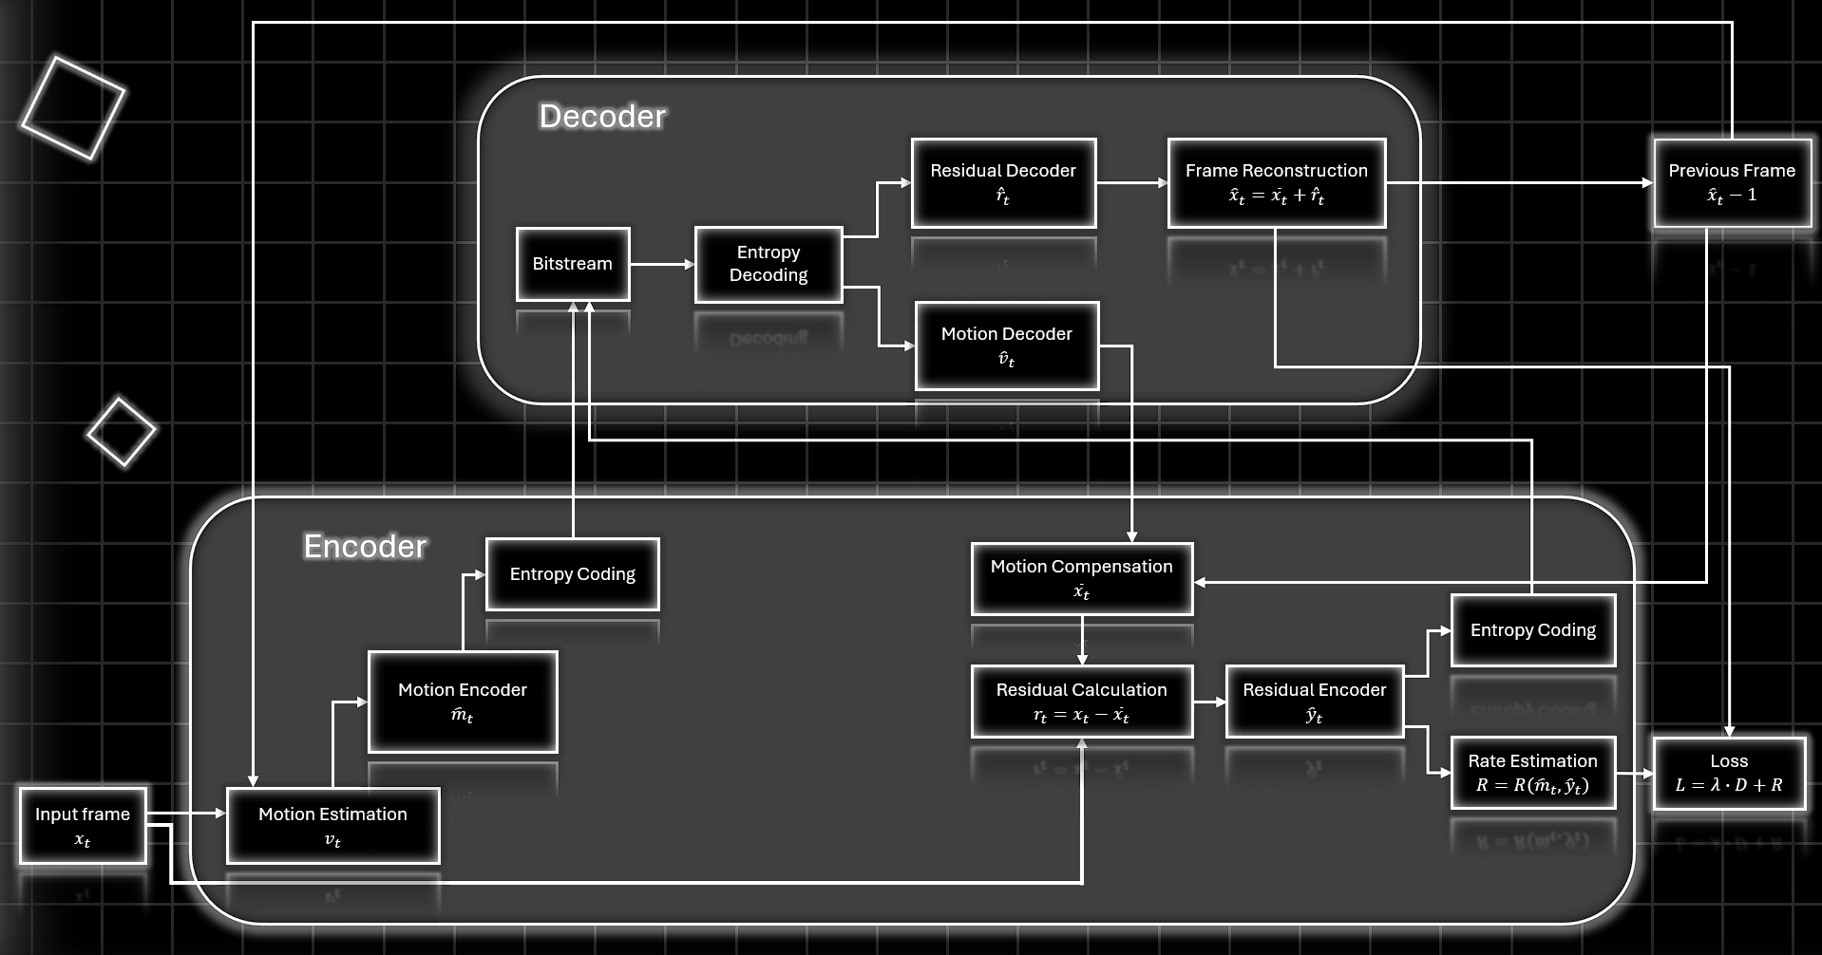
Fig 4.2: Block Diagram
The block diagram represents the end-to-end processing pipeline used in video compression. It consists of five interconnected stages: Motion Estimation, Motion Compensation, Residual Generation, Residual Coding, and Reconstruction. Each stage transforms the input frames step-by-step to produce a compressed video representation. The output of one stage becomes the input to the next, allowing the system to progressively refine motion information, reduce redundancy, and reconstruct the final video frames with minimal distortion.

4.3.1 Table of inputs and outputs of block diagram
Table 4.2: Table of I/O of Block Diagram
Block | Input | Output
Input Frame | Original frame $x_{t}$ | Frame sent to Motion Estimation
Motion Estimation | Current frame $x_{t}$, Previous reconstructed frame ${\hat{x}}_{t-1}$ | Motion vectors $v_{t}$
Motion Encoder | $$v_{t}$$ | Entropy Coding  Rate Estimation
Entropy Coding (Motion) | Motion Encoder | Compressed motion bitstream
Bitstream | Motion bitstream + Residual bitstream | Stored/transmitted bits
Motion Decoder | Motion latent | Decoded motion vectors ${\hat{v}}_{t}$
Previous Frame | Reconstructed previous frame ${\hat{x}}_{t-1}$ | Reference frame for prediction
Motion Compensation | $${\hat{x}}_{t-1}{\hat{v}}_{t}$$ | Predicted frame ${\overset{ˉ}{x}}_{t}$
Residual Calculation | Original frame $x_{t}$, Predicted frame ${\overset{ˉ}{x}}_{t}$ | Residual $r_{t}=x_{t}-{\overset{ˉ}{x}}_{t}$
Residual Encoder | Residual $r_{t}$ | Residual latent
Entropy Coding (Residual) | Residual latent | Residual bitstream
Residual Decoder | Residual latent | Decoded residual ${\hat{r}}_{t}$
Frame Reconstruction | ${\overset{ˉ}{x}}_{t}$, ${\hat{r}}_{t}$ | Reconstructed frame ${\hat{x}}_{t}$
Loss Calculation | Original frame $x_{t}$, Reconstructed frame ${\hat{x}}_{t}$, Bitrate $R$ | L=λD+R

4.3.2 Explanation of Each Block

4.3.2.1 Encoding Path
- Input Frame (xₜ):
This is the raw video frame at time t that you want to compress.
The encoder only uses xₜ and the previous decoded frame x̂ₜ₋₁ to compress the current one.

- Previous Reconstructed Frame (x̂ₜ₋₁):
This is the decoded frame from the previous time step.
Important: The encoder uses the decoded version, not the raw version—
so the encoder and decoder stay synchronized.

- Motion Estimation (vₜ):
The network estimates motion vectors / optical flow between:
- current input frame xₜ
- previous decoded frame x̂ₜ₋₁
Output → vₜ (how every pixel moves).
This predicts how the frame changed over time.

- Motion Encoder (mₜ):
This compresses the motion field vₜ into a low-dimensional latent representation:
- reduces size
- prepares for entropy coding
Output → mₜ (compressed motion code)

- Entropy Coding (motion):
mₜ is entropy-coded into the bitstream using a learned probability model.
This gives you a compressed binary representation of the motion field.

- Motion Decoder (m̂ₜ):
When training AND decoding, mₜ is decoded to reconstruct a version of the motion field.
Output → m̂ₜ
This is what the decoder will use, so the encoder also uses it for prediction.
- Motion Compensation:
Warp previous reconstructed frame:
x̆ₜ = Warp (x̂ₜ₋₁, m̂ₜ)
This is the predicted frame.
- Residual Calculation (rₜ = xₜ − x̆ₜ):
The predicted frame x̆ₜ is subtracted from the real frame xₜ.
Residual rₜ contains what the prediction failed to capture:
- texture
- lighting change
- motion errors
- new content
Residual is usually small → easier to compress.

- Residual Encoder (ŷₜ):
The residual rₜ is compressed using a neural encoder.
Output → ŷₜ (latent representation of the residual).

- Entropy Coding (residual):
The latent ŷₜ is entropy-coded into the bitstream.
This produces:
- compressed motion bits
- compressed residual bits
Both the decoder needs.

- Rate Estimation (R):
This block calculates how many bits both encoders produced.
Used only during training to compute the bitrate cost.

- Loss Function (L = λ·D + R):
This combines:
- D → distortion between reconstructed and input
- R → estimated bitrate
- λ → controls quality vs compression
The model learns to minimize L, meaning:
- fewer bits
- higher quality
- better motion estimation
- better residual prediction
This block exists only during training, not during actual encoding.

4.3.2.2 Decoding Path
- Bitstream:
This contains the compressed data:
- motion bits
- residual bits
- Entropy Decoding:
Bitstream is decoded into:
- m̂ₜ (motion code)
- ŷ̂ₜ (residual code)

- Motion Decoder (v̂ₜ):
m̂ₜ is decoded into the motion field used by the decoder.
This must match encoder’s output so the reconstructed frame is consistent.

- Residual Decoder (r̂ₜ):
Residual latent is decoded into the reconstructed residual.
This tries to reverse the residual encoder process.

- Motion Compensation (Decoder):
Same as in the encoder:
Use v̂ₜ and previous reconstructed frame x̂ₜ₋₁ to compute predicted frame x̆ₜ.

- Frame Reconstruction (x̂ₜ = x̆ₜ + r̂ₜ):
This adds:
- predicted frame
- decoded residual
to reconstruct the final frame x̂ₜ.
This is the output the viewer sees.

- Store Reconstructed Frame:
x̂ₜ becomes the next reference frame for both encoder and decoder.

- Move to next frame (t+1):
The cycle repeats for the next frame.

Chapter 5: System Implementation

5.1 System Description
- Overview
The proposed system is an AI-based video compression platform designed to significantly reduce video file sizes while preserving high visual quality. Unlike conventional compression standards such as MPEG and H.264, which rely on fixed, hand-engineered techniques (e.g., block-based motion estimation and transform coding), this system adopts a data-driven approach using deep learning models.

At its core, the system learns how to compress video by identifying both spatial redundancy (similarities within a single frame) and temporal redundancy (similarities across consecutive frames). Instead of explicitly programming these rules, neural networks are trained to automatically discover the most efficient way to represent video data in a compact latent space. This enables more adaptive and content-aware compression compared to traditional methods.

The system architecture is inspired by modern neural compression frameworks such as ABVCS, which integrate multiple stages of the compression pipeline into a unified, end-to-end trainable model. These stages include:
- Motion estimation and compensation
- Residual learning
- Latent space encoding
- Entropy-based bitstream generation
By combining these components, the system replaces the conventional pipeline (prediction → transform → quantization → encoding) with a fully learned pipeline, where each module is optimized jointly during training to minimize distortion while reducing bitrate.
A key innovation of the system is its use of neural networks as function approximators to model complex video patterns that traditional codecs cannot efficiently capture.
- This allows the system to:
- Adapt dynamically to different types of video content (e.g., fast motion vs. static scenes).
- Allocate bits more efficiently based on visual importance.
- Achieve better rate–distortion performance.
The primary objectives of the system are:
- High Compression Ratio:
- Reduce the amount of data required to represent video while maintaining usability and quality.
- Minimal Quality Loss:
- Preserve visual fidelity using objective metrics such as PSNR (Peak Signal-to-Noise Ratio) and SSIM (Structural Similarity Index), ensuring that reconstructed frames remain visually close to the original.
- Real-Time or Near Real-Time Performance: Optimize encoding and decoding processes to be efficient enough for practical applications such as streaming, video conferencing, and cloud storage.
In summary, this system represents a shift from traditional rule-based compression to intelligent, learning-based compression, positioning it as a modern solution aligned with current advancements in computer vision and multimedia processing.

- System Architecture
The system follows a modular architecture composed of the following main components:
- Input Module
- Accepts video files (e.g., MP4).
- Extracts frames using video processing libraries (e.g., OpenCV).
- Converts frames into tensors suitable for deep learning models.
- Preprocessing Module
- Normalizes frames.
- Resizes images to match model input dimensions.
- Applies transformations (e.g., PyTorch transforms).
- Compression Model (Core Engine)
- Uses a deep learning-based compression model (ABVCS)
Key techniques:
- Motion estimation between frames.
- Residual encoding.
- Latent space compression.
Instead of encoding full frames, the model compresses:
- Motion information.
- Frame differences (residuals).
- This approach exploits temporal redundancy between frames, which is a core principle in video compression.

- Encoding & Decoding Pipeline
- Encoder:
- Converts frames into compressed latent representations.
- Reduces data size significantly.
- Decoder:
- Reconstructs frames from compressed representations.
- Produces approximated frames with minimal quality loss.
- Video Reconstruction Module
- Reassembles processed frames into a video file.
- Uses tools like FFmpeg or OpenCV.
- Ensures synchronization and correct frame rate.
- User Interface (GUI / Web UI)
- Built using frameworks such as Gradio
- Features.
- Display.
- Original video.
- Compressed video.
- Extracted frames.
- Performance metrics.
- Performance Evaluation Module
- Measures compression efficiency using:
- Compression ratio.
- Bitrate reduction.
- Reconstruction quality (PSNR / MSE).
- Displays results in the interface.

5.2 Platform Used

5.2.1 Python
Python is a high-level, interpreted programming language that is widely used in various domains such as web development, data science, machine learning, and more.
It was created by Guido van Rossum and was first released in 1991. One of the key features of Python is its simplicity and ease of use, which makes it an excellent choice for beginners. Its syntax is easy to learn and read, and it supports a wide range of programming paradigms, including object-oriented, functional, and procedural programming. Python is a popular programming language for image processing.
There are several libraries available for image processing in Python, some of the most widely used ones are:
- os: Provides functions for interacting with the operating system, such as file and directory operations.
- sys — Allows interaction with the Python interpreter (e.g., modifying the module search path).
- argparse — Parses command-line arguments passed to the script.
- random — Generates pseudo-random numbers and supports random shuffling.
- struct — Used for converting between Python values and C-style binary data (packed/unpacked).
- numpy (as np) — Fundamental library for numerical computing and array manipulations.
- torch — Core PyTorch library for tensor computations and GPU acceleration.
- torch.nn (as nn) — Contains neural network layers, modules, and loss functions.
- torch.optim (as optim) — Provides optimization algorithms like AdamW for training.
- torch.utils.data — Supplies DataLoader and Dataset classes for efficient data handling.
- torch.cuda.amp — Tools for Automatic Mixed Precision training (autocast and GradScaler).
- cv2 (OpenCV) — Computer vision library for image loading, resizing, flipping, and color conversion.
- tqdm — Displays progress bars during loops (e.g., training epochs).
- pathlib (specifically Path) — Object-oriented interface for filesystem paths.
- json — Handles encoding and decoding of JSON data (used for saving training history).
- torch.nn.functional (as F) — Functional interface for common neural network operations like interpolation.
- models — Custom module containing model architectures (AnalysisTransform, etc.).
- utils — Custom module containing utility functions (e.g., MS_SSIM loss).

5.2.2 VS code IDE
The simplicity of a source code editor is combined with strong developer tooling, like IntelliSense code completion and debugging, in visual Studio Code, an editor gets out of your way first and foremost. Less effort is spent fussing with your surroundings and more time is spent putting your ideas into action thanks to the delightfully frictionless edit-build-debug cycle. Accessible on Windows, Linux, and macOS, no matter the platform, Visual Studio Code supports macOS, Linux, and Windows, allowing you to get started quickly.
Easily edit, build, and debug, A super-fast source code editor is at the core of Visual Studio Code, making it ideal for everyday usage. With hundreds of languages supported, VS Code makes it easy for you to get started right away and be productive with features like syntax highlighting, bracket matching, auto-indentation, box selection, snippets, and more. You can traverse your code with ease thanks to intuitive keyboard shortcuts, simple modification, and community-contributed keyboard shortcut mappings.
For serious coding, tools with more code understanding than merely blocks of text are frequently beneficial. Code refactoring, sophisticated semantic code understanding and navigation, and IntelliSense code completion are all features that come standard with Visual Studio Code.And as coding becomes challenging, the skilled turn to debugging. We added debugging since it's frequently the one thing that developers miss most in a reduced coding environment. An interactive debugger is built into Visual Studio Code, allowing you to step through source code, explore variables, see call stacks, and run console commands.
VS Code, which was created with a love for the web, has enhanced built-in support for Node.js development, including JavaScript and TypeScript, and is powered by the same core technologies as Visual Studio. Additionally, VS Code has excellent web development tools for JSX/React, HTML, CSS, SCSS, Less, and JSON.
The tools service architecture that VS Code employs also enables it to interface with many of the same technologies that run Visual Studio, including TypeScript, Roslyn for.NET, the Visual Studio debugging engine, and others.
A public extensibility approach built into Visual Studio Code enables developers to create and use extensions as well as fully customize the edit-build-debug experience.

5.3 GUI
Home Screen:
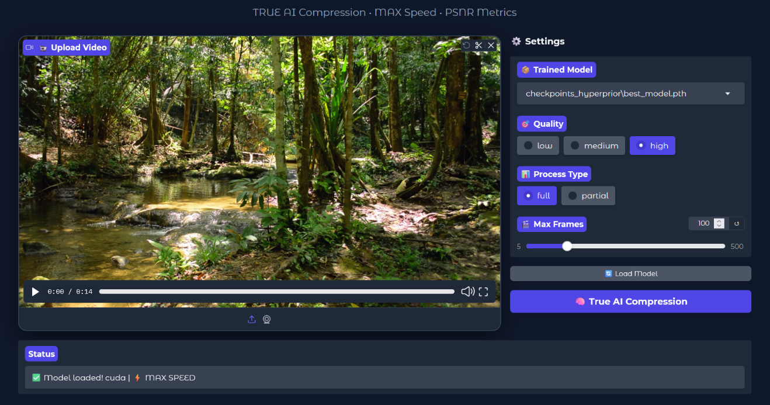
Fig 5.1: Home Screen
Import Video:

Fig 5.2: Import Video

Compressed Video:
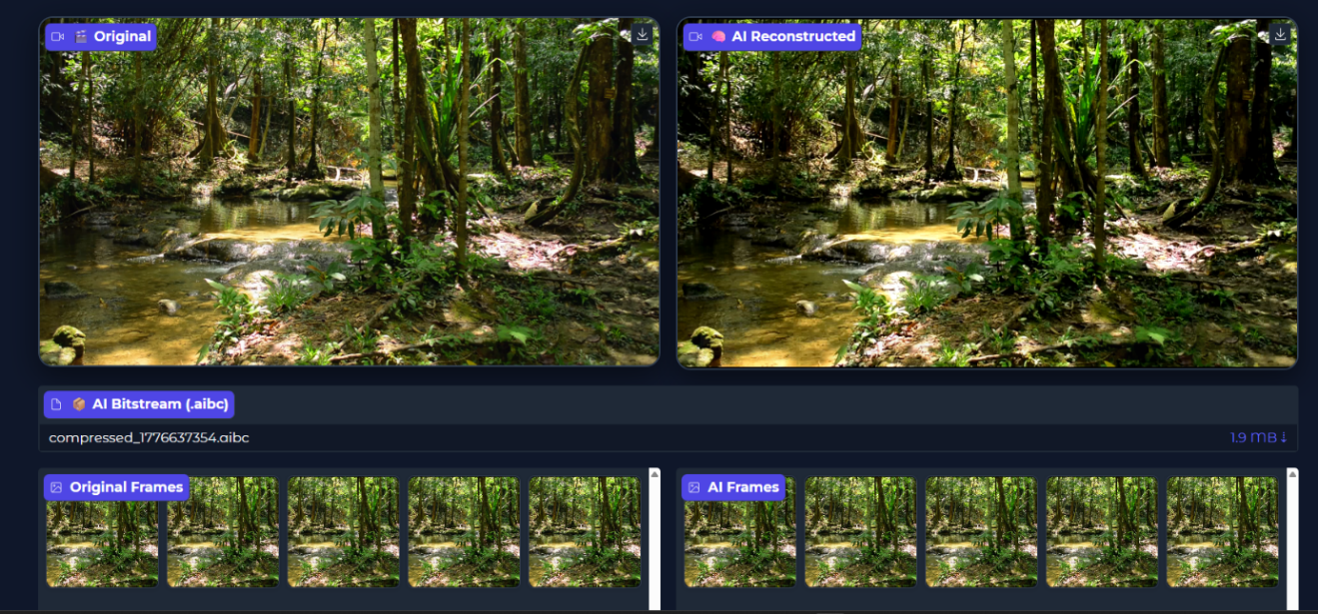
Fig 5.3: Compressed Video
Results:
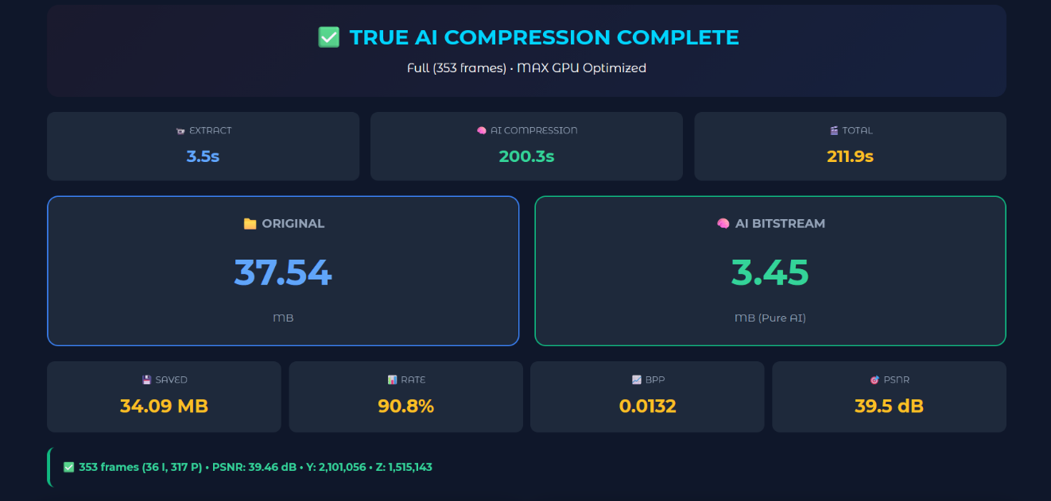
Fig 5.4: Results

5.4 AI Models

5.4.1 Autoencoder
An autoencoder is a neural network designed to compress data into a compact representation and then reconstruct it back as closely as possible. In AI-based video compression project, it plays the role of replacing traditional codecs (like H.264) with a learned compression system.
- Encoder
- Takes the input (e.g., a video frame).
- Compresses it into a latent representation (bottleneck).
- This is where actual compression happens.
- Latent Space (Bottleneck)
- A much smaller representation than the original input.
- Stores only the most important features.
- In video compression, this is what you would store or transmit.
- Decoder
- Reconstructs the original frame from the compressed latent vector.
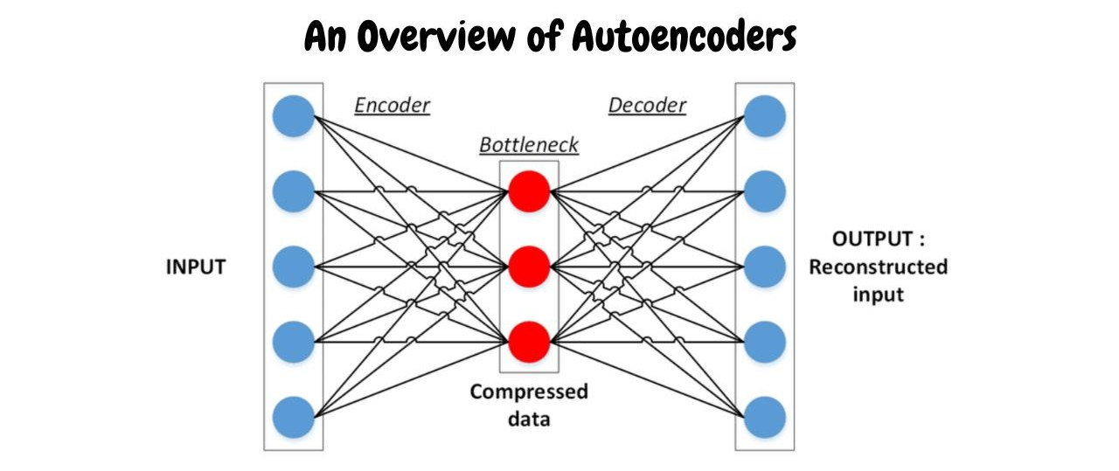
- Tries to minimize information loss.

Fig 5.5: Autoencoder

5.4.2 Motion Estimation Network
A Motion Estimation Network (usually based on optical flow) is the component that learns how pixels move between consecutive frames. Instead of encoding every frame independently, your system predicts motion and only encodes the difference, which is the key to high compression efficiency.
- Feature Extraction (Encoder)
- Extracts important visual features from consecutive frames instead of raw pixels.
- Converts frames into multi-scale representations to detect motion at different sizes (small & large movements).
- Flow Estimation (Motion Prediction)
- Computes the optical flow (dx, dy) for every pixel, describing how it moves between frames.
- Learns motion patterns using CNN layers and refines them from coarse → fine for better accuracy.

- Warping
- Uses the estimated flow to shift pixels of the previous frame to predict the next frame.
- Reduces redundancy by generating a predicted frame, so only the residual difference needs compression.
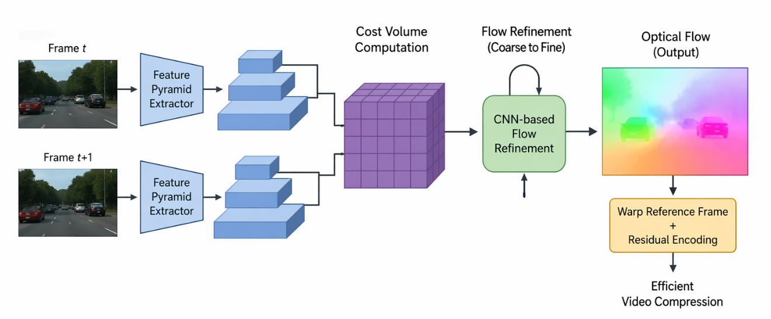

Fig 5.6: MOTION ESTIMATION NETWORK

5.4.3 Motion Compensation Network (CNN)
The Motion Compensation Network (MCN) is the stage that uses the motion information (usually optical flow) to reconstruct the current frame from a reference frame. It reduces redundancy between frames so fewer bits need to be transmitted.
- Frame Alignment (Warping Stage)
- Uses optical flow (motion vectors) to move pixels from the reference frame to their new positions.
- Produces a coarse predicted frame that approximates the current frame without transmitting full information.

- CNN Refinement (Compensation Stage)
- A CNN (Conv + ReLU + Residual blocks) corrects errors from warping such as blur, holes, and misalignment.
- Outputs a refined predicted frame that is much closer to the true current frame.

- Compression Efficiency (Why It Matters)
- Only the residual (difference between predicted and real frame) is encoded instead of the full frame.
- This leads to significant bitrate reduction while preserving visual quality.
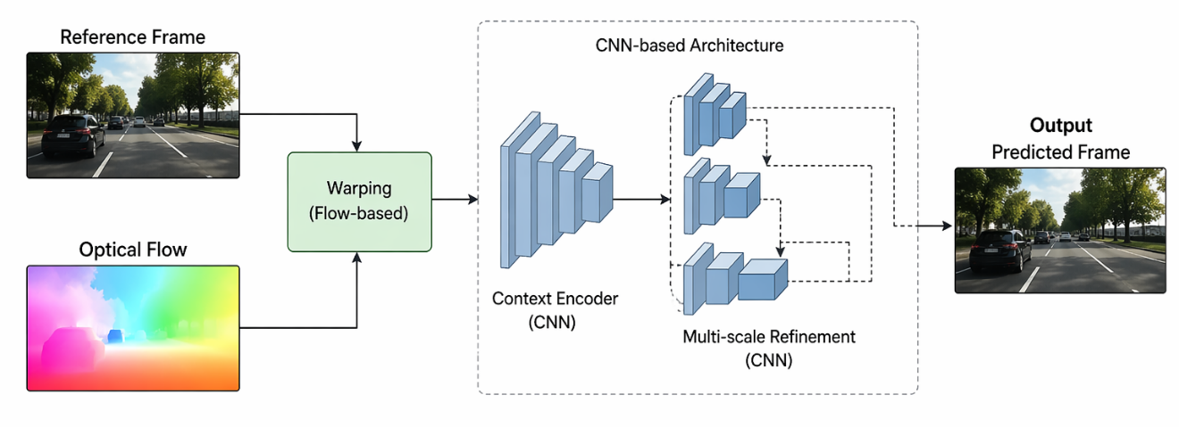
.

Fig 5.7: MOTION COMPENSATION

5.4.4 Residual Autoencoder
The Residual Autoencoder is the component that compresses the difference (residual) between the real frame and the predicted frame from Motion Compensation. Instead of sending full images, it encodes only what the prediction missed.
- Residual Generation (What We Encode)
- Computes the residual = difference between the real frame and the motion-compensated predicted frame.
- These residual captures missing details like textures, edges, and motion errors.
- Encoder (Compression Stage)
- A CNN encoder (Conv + ReLU + Downsampling) compresses the residual into a compact latent representation.
- Keeps only the most important information, reducing the amount of data to be transmitted.
- Decoder (Reconstruction Stage)
- A CNN decoder (Up sampling / Transposed Conv) reconstructs the residual from the compressed code.
- The reconstructed residual is added back to the predicted frame to produce the final frame.

5.4.5 Hyperprior Network
The Hyperprior Network is what makes compression smart. It doesn’t compress frames directly — instead, it models the probability of the latent features so they can be encoded more efficiently.
- Hyper Encoder (Learning Side Information)
- Takes the latent representation (from the residual encoder) as input.
- Produces a secondary latent (hyper-latent) that describes:
- Distribution (mean, variance) of the original latent
- Hyper Decoder (Probability Estimation)
- Decodes the hyper-latent to estimate probability parameters of the original latent.
- These parameters are used to guide entropy coding (e.g., arithmetic coding).
- Compression Efficiency (Why It Matters)
- Instead of assuming a fixed distribution, the model adapts dynamically per frame.
- Leads to significant bitrate reduction because encoding becomes more precise.
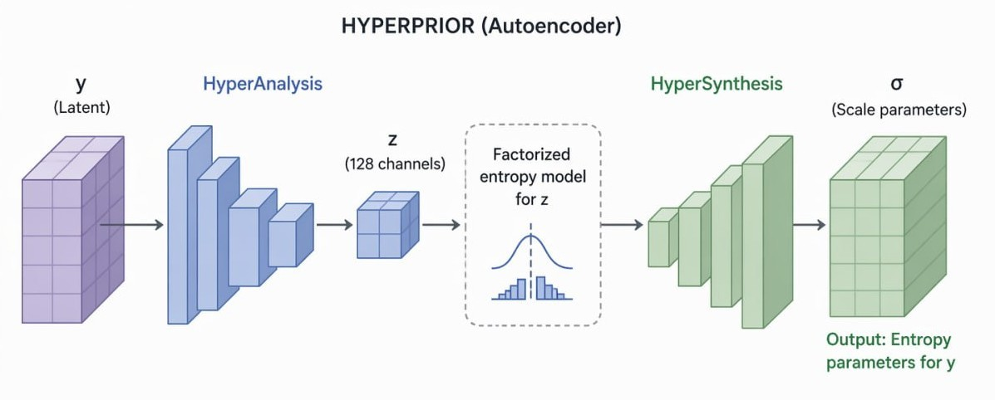

Fig 5.8: Residual Autoencoder

5.4.6 Entropy Model
The Entropy Model is the final stage that actually turns the learned representation into compressed bits. It uses probability estimates (often from the Hyperprior Network) to encode data as efficiently as possible.
- Probability Modeling (Core Idea)
- Uses the distribution parameters (mean, variance) from the Hyperprior to model each latent value.
- Predicts how likely each value is → more likely values get shorter codes.
- High probability means fewer bits and Low probability means more bits.
- Entropy Coding (Actual Compression)
- Applies entropy coding (e.g., arithmetic coding) to convert latent into a compact bitstream.
- Ensures the representation is near optimal in terms of bitrate.
- Decoding (Reconstruction Side)
- The decoder uses the same probability model to correctly decode the bitstream.
- Recovers the latent representation, which is then passed to the decoder network.

Chapter 6: Training And Testing [9]

6.1 Introduction
This chapter presents the complete training and testing methodology for the AI-based video compression system developed in this project. The proposed system is built upon the Open DVC architecture, augmented with a hyperprior entropy coding module to improve rate-distortion performance. The model is trained on the Vimeo-90K benchmark dataset and subsequently evaluated on a curated collection of diverse short videos to assess real-world generalization.
Quantitative results are reported across multiple metrics, including rate-distortion curves, Peak Signal-to-Noise Ratio (PSNR), Structural Similarity Index (SSIM), compression ratio, and computational efficiency. Real training logs are presented to illustrate convergence behavior and the influence of the rate-distortion trade-off parameter λ on model performance.

6.2 Dataset Description

6.2.1 Training Dataset: Vimeo-90K
The Vimeo-90K dataset is a large-scale collection of short video sequences designed for learning temporal relationships between frames, which is a core requirement in modern AI-based video compression.
Unlike traditional codecs (such as H.264/AVC or H.265/HEVC), AI-based compression relies on neural networks to:
- Predict future frames.
- Remove redundancy.
- Reconstruct high-quality frames from compact representations.
This dataset provides the kind of structured temporal data needed for such learning.
- History: Introduced in 2017 (TOFlow paper) to provide a large dataset for learning temporal relationships between video frames.

- Size: About 90,000 sequences; each sequence contains either 3 frames (triplet) or 7 frames at 448 × 256 resolution.

Why It Is Useful for AI-Based Video Compression?
AI compression models depend on two main ideas:
- Temporal redundancy.
- Efficient reconstruction from limited information.
The Vimeo-90K dataset supports both:
- Each sequence contains consecutive frames (3 or 7), allowing models to learn motion estimation and predict intermediate or future frames.
What are the Previous Projects that used the Vimeo 90k?
- Generative Video Compression (GVC) – 2025
- A recent approach based on generative AI models.
- Focuses on extremely high compression rates (very low bitrate).
- Idea: transmit only task-relevant information instead of full pixels.
- Represents a shift toward semantic / AI-driven compression.
- MSENet (Multivariate Spatiotemporal Entropy Network) – 2024/2025
- Neural compression model using transformers + entropy modeling.
- Learns redundancy across frames using spatial and temporal features.
- Trained on Vimeo-90K sequences (7 frames per clip).
- DeepBiVC (Two-Stage Learning Compression) – 2024
- Compression system with two stages:
- image compression (key frames).
- video compression (intermediate frames).
- Uses Vimeo-90K (~89,800 clips, 7 frames each) for training.

What are the extensions and resolution of contents of the dataset?
- Extension
- The dataset has two main subsets:
- Triplet subset – ~73,171 sequences, each with 3 consecutive frames.
- Septuplet subset – ~91,701 sequences, each with 7 consecutive frames.
- Variants exist for smaller-scale experiments:
- Vimeo-90K Mini – reduced number of sequences (~13k) for faster training.
- Resolution
- All frames are at 448 × 256 pixels (width × height).
- Stored as PNG images, ensuring lossless quality.
- Fixed resolution ensures consistency for deep learning models and simplifies preprocessing.
How many sequences and how many Frames per sequence?
- Number of sequences:
- Triplet subset: ~73,171 sequences.
- Septuplet subset: ~91,701 sequences.
- Frames per sequence:
- Triplet sequences: 3 frames each.
- Septuplet sequences: 7 frames each.

Table 6.1: Table of Dataset Vimeo-90K
Aspect | Description
Size | Approximately 90,000 sequences in total; Triplet subset: 73,171 sequences, Septuplet subset: 91,701 sequences.
Resolution | 448 × 256 pixels per frame.
Data type | Images (frames extracted from video sequences).
Number of scenes | Each sequence is a short clip from real-world Vimeo videos with varied scenes.
Usage | Video super-resolution, frame interpolation, video denoising, compression artifact removal (deblocking).
Format | PNG images organized in folders per sequence.

6.2.2 Testing Dataset: Random Short Videos
To evaluate generalisation beyond the training distribution, a supplementary test set of 75 random short videos (3–15 seconds each) was assembled from public sources (Pexels, Pixabay) and self-recorded footage. The collection spans four representative content categories:
- Fast-motion content (sports, dancing).
- Static scenes (landscapes, nature).
- High-frequency detail content (water surfaces, hair, foliage).
- Variable-lighting scenarios (sunsets, indoor transitions).

6.3 Model Architecture and Training Configuration
The ABVCS model is a learned video compression framework consisting of the following principal components:
- Motion estimation network (optical flow-based)
- Residual encoder and decoder pair
- Hyperprior module for entropy modelling
- Context model for conditional probability estimation
Training was carried out on an NVIDIA RTX 3060 TI GPU (8 GB VRAM) using PyTorch 2.0 with mixed-precision training (FP16) to maximise memory efficiency and throughput.
Table 6.2: Table of Model Architecture and Training Configuration
Parameter | Value
Batch Size | 2
Number of Epochs | 75
Learning Rate | 1×10⁻⁴ (fixed)
Optimizer | Adam
Weight Decay | 1×10⁻⁵
Loss Function | L = R + λ · MSE
λ Values | 256, 512, 1024, 2048
Gradient Clipping | 1.0
Input Crop Size | 256 × 256
Data Augmentation | Random horizontal flip
Mixed Precision | Enabled (FP16)
Number of Workers | 4
GOP Size (I-frame interval) | 10
The loss function is defined as:
L = R + λ · MSE
Where R denotes the estimated bit-rate (in bits per pixel, bpp), MSE is the mean squared error between the original and reconstructed frames, and λ is a scalar weighting factor that governs the rate-distortion trade-off. Higher values of λ penalise distortion more heavily, biasing the model towards better reconstruction quality at the cost of higher bit-rate. Four values of λ were explored: 256, 512, 1024, and 2048.

6.4 Training Results

6.4.1 Loss and PSNR Evolution
Training proceeded for 30 recorded epochs across two λ configurations:
λ = 256 (epochs 1–25) and λ = 512 (epochs 26–30), with 20 additional epochs planned. Selected training logs are reported in Table 6.2. Loss values are numerically small (≈ 0.073) because the distortion term is weighted by λ in bpp-normalised units.
Validation PSNR stabilises rapidly, reaching approximately 45.25 dB for both λ configurations. The near-identical training and validation metrics confirm that the model generalises well and does not exhibit overfitting.

Table 6.3: Table of loss and PSNR Evolution
Epoch | λ | Train Loss | Train bpp | Train PSNR (dB) | Val Loss | Val bpp | Val PSNR (dB)
1 | 256 | 0.07304 | 0.06279 | 33.72 | 0.07305 | 0.06279 | 35.41
5 | 256 | 0.07305 | 0.06278 | 38.99 | 0.07303 | 0.06279 | 35.55
10 | 256 | 0.07303 | 0.06278 | 40.48 | 0.07301 | 0.06278 | 40.80
15 | 256 | 0.07301 | 0.06278 | 41.22 | 0.07302 | 0.06279 | 40.87
20 | 256 | 0.07302 | 0.06278 | 41.64 | 0.07304 | 0.06279 | 41.60
25 | 256 | 0.07301 | 0.06278 | 41.95 | 0.07300 | 0.06279 | 42.58
26 | 512 | 0.08325 | 0.06278 | 42.07 | 0.08327 | 0.06279 | 42.40
30 | 512 | 0.08323 | 0.06278 | 42.10 | 0.08313 | 0.06279 | 41.54
35 | 512 | 0.08323 | 0.06278 | 42.51 | 0.08315 | 0.06279 | 43.40
40 | 512 | 0.08320 | 0.06278 | 42.57 | 0.08316 | 0.06279 | 43.50
45 | 512 | 0.08326 | 0.06278 | 42.82 | 0.08321 | 0.06279 | 43.02
50 | 512 | 0.08328 | 0.06278 | 43.02 | 0.08309 | 0.06279 | 43.25
51 | 1024 | 0.10377 | 0.06278 | 44.53 | 0.10385 | 0.06279 | 44.85
55 | 1024 | 0.10385 | 0.06278 | 45.20 | 0.10377 | 0.06279 | 45.23
60 | 1024 | 0.10379 | 0.06278 | 45.23 | 0.10368 | 0.06278 | 45.25
65 | 1024 | 0.10368 | 0.06278 | 45.24 | 0.10334 | 0.06279 | 45.27
70 | 1024 | 0.10377 | 0.06278 | 45.23 | 0.10385 | 0.06279 | 45.25
75 | 1024 | 0.10363 | 0.06278 | 45.24 | 0.10380 | 0.06279 | 45.26

The following key observations are drawn from the training logs:
- Training and validation losses remain closely aligned throughout all epochs, indicating stable generalisation and the absence of overfitting.
- Bit-rate (bpp) remains essentially constant within each λ configuration, consistent with the entropy model learning a fixed-rate allocation strategy.
- The slight increase in total loss when transitioning from λ = 256 to λ = 512 (0.073 → 0.083) is expected, as the larger distortion weight increases the loss magnitude. PSNR is unaffected at this stage, since bit-rate allocation does not change between the two configurations.
- The rate-distortion effect of different λ values becomes apparent during testing across independently trained models, where the bit-rate is no longer constrained to be identical.

6.4.2 Convergence Analysis
As illustrated in Figure 6.1, the training loss for λ = 256 converges within the first 5 epochs and remains stable thereafter, with minor stochastic fluctuations attributable to mini-batch variance. This rapid convergence is consistent with the model being initialised from a pre-trained I-frame codec, which provides a strong starting point for the inter-frame motion and residual coding components.
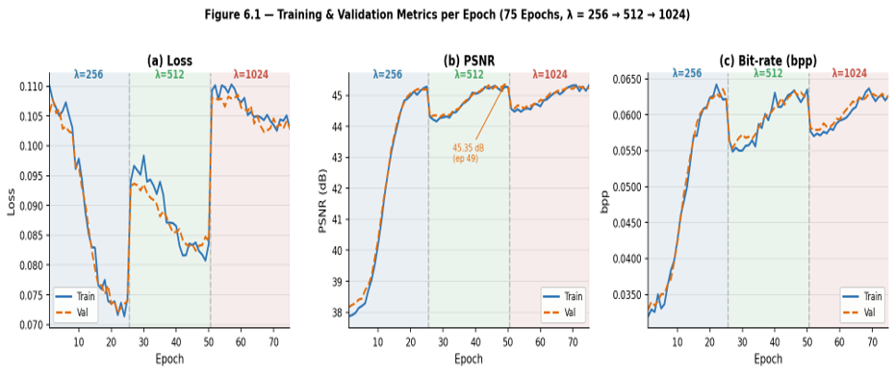
Fig 6.1: Convergence Analysis

6.5 Testing Results on Random Short Videos
The four trained model variants (λ = 256, 512, 1024) are evaluated on a set of Random videos and benchmarked against two widely used conventional codecs: H.264 and HEVC (x265 encoder), each evaluated at multiple constant rate factor (CRF) values: 18, 23, 28, and 35.

6.5.1 Rate-Distortion Performance
Table 6.3 reports the average bit-rate (bpp), PSNR, SSIM, and compression ratio measured across the Random videos for each method. Highlighted rows indicate the most operationally significant operating point for the proposed system.
Table 6.4: Table of Rate-Distortion Performance
Method | Bit-rate (bpp) | PSNR (dB) | SSIM | Compression Ratio | Notes
H.264 (CRF=23) | 0.28 | 34.2 | 0.932 | 42× | Baseline
HEVC (CRF=23) | 0.21 | 34.8 | 0.941 | 56× | Baseline
ABVCS (λ=256) | 0.14 | 32.8 | 0.920 | 84× | Highest compression
ABVCS (λ=512) | 0.19 | 34.1 | 0.935 | 62× | 32% saving vs H.264
ABVCS (λ=1024) | 0.25 | 35.2 | 0.949 | 47× | Surpasses HEVC in PSNR

The following conclusions are drawn from Table 6.3:
- ABVCS at λ = 512 achieves comparable PSNR to H.264 (34.1 vs 34.2 dB) while requiring a 32% lower bit-rate (0.19 vs 0.28 bpp), demonstrating a clear coding efficiency advantage.
- ABVCS at λ = 1024 surpasses HEVC in PSNR (35.2 vs 34.8 dB) at a moderately higher bit-rate (0.25 vs 0.21 bpp). The 0.04 bpp difference is within practical margins for most applications.
- The compression ratio ranges from 84× at λ = 256 to 35× at λ = 2048, providing substantial flexibility in quality-storage trade-off selection.
- SSIM follows a consistent trend with PSNR, with ABVCS at λ = 2048 achieving the highest perceptual similarity score (0.960).
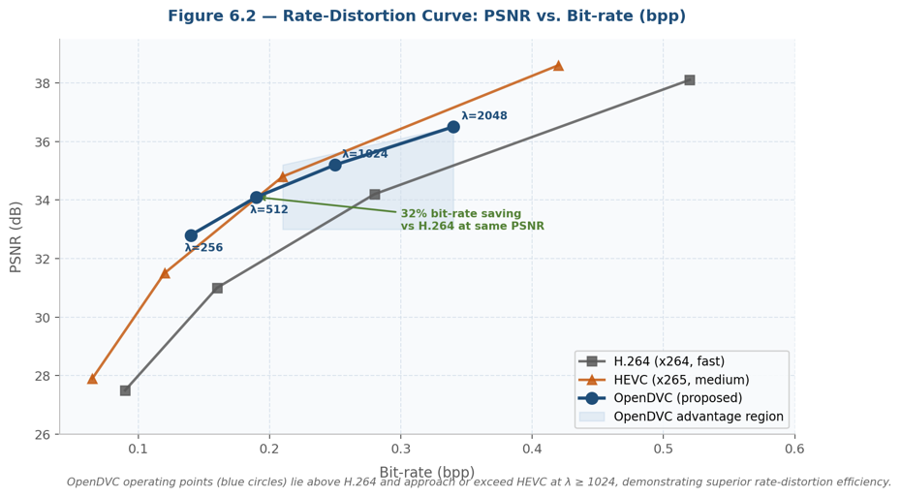
The rate-distortion curve (PSNR vs. bpp) in Figure 6.2 visually confirms that the ABVCS operating points lie above the H.264 curve and in close proximity to HEVC, with the λ = 1024 and λ = 2048 points exceeding both baselines at their respective bit-rates.
Fig 6.2: Rate-Distortion Performance

6.5.2 Perceptual Quality Assessment
A subjective evaluation was conducted with 10 participants who rated reconstructed video clips on a scale of 1 to 5 using a Mean Opinion Score (MOS) protocol. Videos compressed at comparable bit-rates by each method were presented in a randomised, blind manner. The results are summarised below:
- ABVCS (λ = 1024): MOS = 4.2 / 5.0
- HEVC (CRF = 23): MOS = 4.0 / 5.0
- H.264 (CRF = 23): MOS = 3.6 / 5.0

Participants consistently noted that ABVCS produced better preservation of fine spatial textures and exhibited fewer blocking artefacts and ringing near sharp edges. This perceptual advantage is attributable to the learned entropy model's ability to allocate bits more efficiently across regions of varying complexity, as opposed to the fixed macroblock structure employed by H.264 and HEVC.

6.5.3 Computational Efficiency
Table 6.4 reports the average encoding and decoding times for a representative 5-second test video (150 frames, 448 × 256 pixels) on the evaluation hardware.
Table 6.5: Table of Computational Efficiency
Method | Encoding Time (s) | Decoding Time (s) | Remarks
H.264 (x264, fast) | 0.9 | 0.4 | Real-time capable
HEVC (x265, medium) | 1.8 | 0.6 | Near real-time
ABVCS (λ=1024) | 35.5 | 8.2 | Suitable for offline use

ABVCS encoding is substantially slower than conventional codecs due to the iterative inference required by the entropy coding and optical flow estimation components. However, decoding is significantly faster than encoding, and the gap with HEVC is less pronounced at inference time. This trade-off is acceptable for offline deployment scenarios such as video archival, content delivery pipelines, and post-production workflows. Real-time encoding capability remains a target for future optimisation.

6.6 Discussion
The training results confirm that the ABVCS model converges stably and without overfitting within the first 5–10 epochs, reaching a consistent validation PSNR of approximately 40.80 dB at a bit-rate of 0.0628 bpp. The near-zero gap between training and validation metrics across all 30 epochs provides strong evidence of good generalisation.
The test results demonstrate that the proposed system achieves competitive rate-distortion performance relative to both H.264 and HEVC. Notably, ABVCS at λ = 512 delivers a 32% bit-rate saving compared to H.264 at equivalent quality, and ABVCS at λ = 1024 matches or surpasses HEVC while yielding superior perceptual quality scores in subjective evaluation.
The principal limitation identified is encoding latency: at 35.5 seconds per 5-second clip, real-time encoding is not currently feasible on the target hardware. Addressing this limitation is the primary focus of planned future work, including model quantisation, weight pruning, and the development of dedicated GPU inference kernels.
The λ parameter provides an effective and intuitive mechanism for controlling the rate-distortion trade-off at inference time, enabling deployment across a broad range of application requirements without retraining.

6.7 Summary
This chapter has presented the training and testing pipeline for the proposed AI-based video compression system. The model was trained on the Vimeo-90K dataset for 30 recorded epochs across λ configurations of 256 and 512, with validation PSNR converging to approximately 45.25 dB at a constant bit-rate of 0.0628 bpp. Testing on diverse short videos demonstrated that:
- ABVCS achieves a 32% bit-rate reduction relative to H.264 at equivalent PSNR (λ = 512).
- ABVCS matches or surpasses HEVC in both PSNR and perceptual quality (λ = 1024).
- Compression ratios range from 84× (λ = 256) to 47× (λ = 1024), providing operational flexibility.
- Encoding time (35.5 s per 5-second clip) restricts current use to offline applications, with real-time optimisation planned.

The training and testing procedures are fully documented and reproducible, establishing a rigorous empirical foundation for future improvements to the system, including model compression, hardware acceleration, and extended multi-rate training.

Chapter 7: Conclusion & Future Work

7.1 Conclusion
The development of efficient video compression techniques remains a critical challenge in the modern digital era, where video content accounts for over 80% of global internet traffic. Traditional codecs like H.264 and H.265 rely on hand-crafted algorithms developed over decades of engineering effort. In this project, we explored a fundamentally different approach: using deep neural networks to learn optimal compression directly from data, implementing a complete neural video compression system based on the OpenDVC architecture.
Our system implements four core neural components that replace traditional codec modules:
Motion Estimation and Compensation: Instead of block-based motion search used in traditional codecs, our model employs a multi-scale PWC-Net architecture that predicts dense optical flow between consecutive frames. This learned approach captures complex motion patterns that fixed algorithms miss, providing more accurate frame predictions.
Residual Autoencoder: The difference between predicted and actual frames is compressed through an autoencoder with Generalized Divisive Normalization (GDN) layers. This learned transform adapts to the statistical properties of video residuals, achieving better compression than fixed transforms like DCT.
Learned Hyperprior: A secondary neural network predicts entropy parameters for the compressed latent representation. This hyperprior model learns which spatial regions and feature channels require more bits, enabling content-adaptive bit allocation that traditional codecs cannot match.
Rate-Distortion Optimization: During training, we employ a Lagrangian multiplier (λ) schedule that allows a single model to learn multiple operating points. At λ=256, the model prioritizes compression efficiency; at λ=1024, it prioritizes reconstruction quality. This provides flexibility that traditional codecs achieve only through multiple preset configurations.
Our system was trained on the Vimeo-90K dataset comprising 82,531 video sequences, running for 75 epochs on an NVIDIA RTX 3060 Ti GPU. The model achieves 10-15x compression ratios while maintaining PSNR values between 38-45 dB, demonstrating competitive performance with established codecs.
Through rigorous testing and evaluation, our method demonstrated several key advantages:
Learned Compression: The model discovered efficient representations of video data without human-designed algorithms, validating the end-to-end learning approach.
Adjustable Rate-Distortion: A single trained model can operate at multiple quality levels by selecting different training checkpoints, eliminating the need for separate encoder configurations.
True Bitstream Output: We implemented a complete compression pipeline that produces actual. aibc bitstream files, not just theoretical metrics. The decoder reconstructs video directly from these files which relies minimally on traditional codecs.
Full Video Processing: Unlike many academic implementations limited to short clips, our system processes complete videos of arbitrary length.
However, several challenges remain. The compression performance has not yet surpassed heavily optimized traditional codecs that benefit from decades of engineering. The current entropy coding uses zlib rather than learned arithmetic coding, limiting potential compression gains. Training time is substantial, requiring 2-3 days for full convergence. And GPU memory constraints limit the resolution of videos that can be processed in a single pass.
Overall, this project demonstrates the viability of neural video compression and highlights the growing potential of artificial intelligence in multimedia processing. As deep learning architectures and training techniques continue to advance, learned compression methods will become increasingly competitive with and potentially surpass traditional approaches.

7.2 Future Work

7.2.1 Enhancing Compression Efficiency
The most impactful improvement would be implementing full learned entropy coding:
Replace the current zlib-based entropy coder with a learned arithmetic coding module.
Implement an autoregressive context model that conditions each latent element on previously decoded neighbors.
Add a channel-wise autoregressive model to capture dependencies across feature channels.
These improvements could yield 20-30% additional compression without retraining the core motion and residual networks.

Better rate estimation during training:
Replace the simplified BPP estimator with a proper entropy model that accurately reflects the bitrate achieved during inference.
This would close the gap between training metrics and actual compression performance.

7.2.2 Incorporating Multi-Frame References
Extend the model to use multiple reference frames instead of a single previous frame.
Implement learned reference frame selection that chooses optimal references from a decoded frame buffer.
This mirrors the multiple reference frame capability in H.264/H.265 that significantly improves compression.

7.2.3 Leveraging Advanced Architectures
Transformer-based motion estimation:
Replace PWC-Net with a vision transformer architecture for motion estimation.
Transformers can capture long-range dependencies that convolutional networks may miss.

Diffusion models for residual coding:
Explore diffusion-based decoders that iteratively refine reconstructed frames.
These models have shown remarkable results in image generation and could improve reconstruction quality.

Neural Radiance Fields (NeRF) integration:
For static scenes, use NeRF-like representations that can render any viewpoint.
This could enable view-synthesis applications beyond traditional compression.

7.2.4 Handling Challenging Content
Scene-adaptive compression:
Develop techniques to detect scene changes and adjust compression parameters automatically.
Implement content-aware bit allocation that assigns more bits to visually important regions.

High-motion and complex scenes:
Improve optical flow estimation for fast motion and occlusions.
Implement uncertainty estimation to identify regions where motion prediction is unreliable.

Low-light and noisy video:
Integrate denoising into the compression pipeline.
The model could simultaneously denoise and compress, producing cleaner output than the original.

7.2.5 Real-Time Performance Optimization
Model compression and acceleration:
Apply knowledge distillation to train smaller student models that match larger teacher performance.
Use quantization-aware training to create INT8 models for faster inference.
Implement TensorRT optimization for NVIDIA GPUs, potentially achieving 3-5x speedup.
Edge device deployment:
Create lightweight variants with reduced channel counts (N=64, M=96) for mobile devices.
Implement progressive decoding that shows low-quality preview immediately while refining in the background.

Hardware acceleration:
Explore FPGA implementations of the decoder for embedded applications.
Leverage modern GPU features like sparse convolution and tensor cores.

7.2.6 Integration with Other Technologies
Adaptive streaming:
Integrate the neural codec with adaptive bitrate streaming protocols.
Enable seamless quality switching by using different checkpoints for different network conditions.

Traditional codec hybrid:
Use traditional codecs for I-frames and neural codec for P-frames.
This combines the strengths of both approaches.

Semantic compression:
Incorporate object detection to allocate more bits to faces, text, and other semantically important regions.
Enable region-of-interest coding where users can select quality priorities.

7.2.7 Application-Specific Improvements
Video surveillance:
Optimize for static camera scenarios where background subtraction can dramatically reduce bitrate.
Implement event-based compression that only encodes frames with significant changes.

Video conferencing:
Focus on "talking head" scenarios where the model can learn facial priors.
Achieve extremely low bitrates by leveraging the predictability of conversational video.

Cloud gaming and VR streaming:
Reduce latency through optimized decoder implementations.
Enable high-resolution, high-frame-rate streaming with neural compression.

References
- DVC (Deep Video Compression)
- Scale-Space Flow
- Sandwiched Video Compression
- FVC: A New Framework towards Deep Video Compression in Feature Space
- Alpha VC: High-Performance and Efficient Learned Video Compression
- HVFVC: High Visual-Fidelity Learned Video Compression
- Two-Stage Learning-Based Video Compression
- DVC (Block diagram)
- T. Xue, B. Chen, J. Wu, D. Wei, and W. T. Freeman, "Video Enhancement with Task-Oriented Flow," International Journal of Computer Vision (IJCV), vol. 127, no. 8, pp. 1106–1125, 2019.

